Transducers 07
Invited Talks

1. CONCEPTS FOR CARBON NANOTUBE SENSORS
Christofer Hierold
Micro and Nanosystems, ETH Zurich, 8092 Zurich, SWITZERLAND
(Tel.: +41 44 63 23143; E-mail: hierold@micro.mavt.ethz.ch)
Abstract: This paper reports on concepts for carbon nanotube based sensors for mechanical and
chemical quantities. We focus on single-walled carbon nanotubes as “simple” macro molecular functional
structures with an option for integration in micro- and nanosystems or MEMS and NEMS and we discuss
topics of relevance for fabrication. An extended reference list is included.
Keywords: nanotransducer, nanosensor, NEMS, carbon nanotube
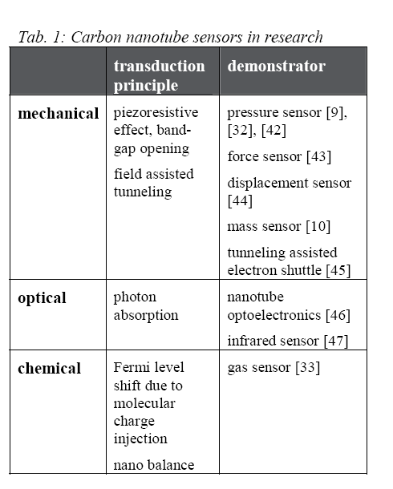

2. USING MEMS TO BUILD THE DEVICE AND THE PACKAGE
B. Kim1, M. Hopcroft1, C.M Jha, R. Melamud1, S. Chandorkar1, M. Agarwal1, K.L. Chen1,
W.T. Park1, R. Candler2, G. Yama2, A. Partridge3, M. Lutz3, T.W. Kenny1
1Departments of Mechanical or Electrical Engineering, Stanford University, Stanford, CA, USA
(Tel : 650 725-3805; E-mail:Kenny@cdr.Stanford.edu)
2Bosch Research and Technology Center, Palo Alto, CA, USA
(Tel : 650 320-2999; E-mail: robert.candler@rtc.bosch.com)
3SiTime Corporation, Sunnyvale, CA, USA
(Tel : 408 328-4401; E-mail: ml@sitime.com)
Abstract:MEMS devices must be packaged to be used. Unfortunately, MEMS packages are challenging
to develop, and the packaging of MEMS devices often dominates the cost of the product. In recent years,
our group has worked with a team from Bosch to develop and demonstrate a novel wafer-scale
encapsulation approach for MEMS. This process uses MEMS fabrication steps to build the device and
the package at the same time. The main advantage of this approach is that the wafers emerge from the
fabrication facility with all the fragile MEMS structures completely buried within the wafer, allowing all
existing standard handling and packaging approaches, such as wafer-dicing, pick/place, and injection
mold packaging to be used. This encapsulation process enables CMOS integration, embedding, and
extreme miniaturization of complete systems. In this paper, we describe some advantages for
performance, size and cost that can come from this approach.
4 Keywords: packaging, encapsulation, resonator, accelerometer

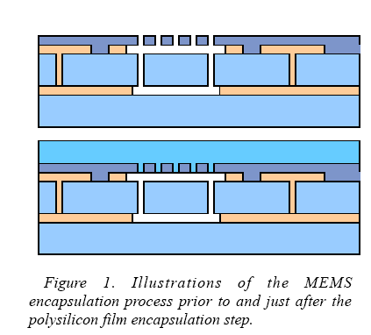
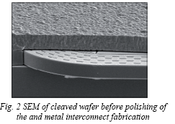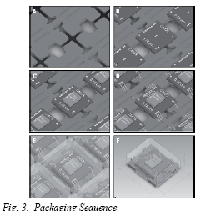
Above 2 pictures from related publication:
MEMS OSCILLATORS FOR HIGH VOLUME COMMERCIAL APPLICATIONS
M. Lutz, A. Partridge, P. Gupta, N. Buchan, E. Klaassen, J. McDonald, K. Petersen
SiTime Corporation, Sunnyvale, USA

Fabrication related

Etching Techniques
1:30 pm - 2:45 pm
1D4.1 Invited Speaker
ACHIEVEMENTS AND PERSPECTIVES OF DRIE
TECHNOLOGY FOR THE MICROSYSTEMS MARKET
M. Puech, J.M. Thevenoud, J.M. Gruffat, N. Launay,
P. Godinat and O. Le Barillec
Alcatel Micro Machining Systems, FRANCE
...........................................................................77
1D4.2 A NEW METHOD FOR HIGH-RATE DEEP DRY
ETCHING OF SILICATE GLASS WITH VARIABLE
ETCH PROFILE
A. Bertz(1), R. Fendler(2), R. Schuberth(1), W. Hentsch(2)
and Th. Gessner(1, 3)
(1) Chemnitz University of Technology, GERMANY
(2) FHR Anlagenbau GmbH, GERMANY
(3) Fraunhofer IZM, GERMANY
...........................................................................81
1D4.3 A NOVEL DEEP HOLE ETCHING IN NLD PLASMA
LOW GWP GASES
Y. Morikawa, T. Murayama and K. Suu
ULVAC, Inc., JAPAN
...........................................................................85
1D4.4 FORMATION OF SILICON NANOPORES AND
NANOPILLARS BY A MASKLESS DEEP REACTIVE
ION ETCHING PROCESS
Z. Xiao, C. Feng, P.C.H. Chan and I-M. Hsing
Hong Kong University of Science & Technology,
CHINA
...........................................................................

Energy Scavanging
3:00 pm - 4:15 pm
1C5.1 A SURFACE MOUNTABLE GLUCOSE FUEL CELL
FOR MEDICAL IMPLANTS
S. Kerzenmacher(1), R. Sumbharaju(1), J. Ducrée(2),
R. Zengerle(1, 2) and F. von Stetten(1)
(1) University of Freiburg, GERMANY
(2) HSG-IMIT, GERMANY
.........................................................................125
1C5.2 HARVESTING ENERGY FROM VIBRATIONS BY A
MICROMACHINED ELECTRET GENERATOR
T. Sterken(1, 2), P. Fiorini(1), G. Altena(3), C. Van Hoof(1, 2)
and R. Puers(2)
(1) IMEC, BELGIUM
(2) Katholieke Universiteit Leuven, BELGIUM
(3) IMEC-NL, THE NETHERLANDS
.........................................................................129
1C5.3 MICROSTRUCTURED IN-PLANE THERMOELECTRIC
GENERATORS WITH OPTIMIZED HEAT PATH
N. Kockmann(1), T. Huesgen(2) and P. Woias(1)
(1) University of Freiburg, GERMANY
(2) Technical University of Munch, GERMANY
MICROSTRUCTURED IN-PLANE THERMOELECTRIC GENERATORS
WITH OPTIMIZED HEAT PATH
N. Kockmann1, T. Huesgen2, P. Woias1
1Design of MEMS, Dept. of Microsystems Engineering (IMTEK), University of Freiburg, GERMANY,
(Tel: +49-761-203-7499, E-mail: kockmann@imtek.uni-freiburg.de)
2now at: Technical University of Munich, Walter-Schottky Institute, Munich, GERMANY
Abstract:
This paper proposes a multipurpose platform with standard thin-film CMOS fabrication technology for
thermocouples for many materials and a high integration density. The heat flow path is perpendicular to
the chip surface (cross-plane) and guided by special thermal connectors. On the thermocouples, a grid
structure with thermally insulating SU-8 and electrodeposited metal stripes connects one junction of the
thermocouple with the environment. The substrate is structured with trenches to connect the other junction
with the environment. About 95% of the total temperature difference is between the two thermocouple
junctions. Test chips with up to 13 460 thermocouples (Al – n-poly-Si) produce an output power of up
to 3.17·10-3 µW/mm2K2 per chip.
Key Words: thermocouple, heat flux, electro deposition, DRIE process, thermogenerator

.........................................................................133
1C5.4 TUNABLE CAPACITOR BASED ON POLYMERDISPERSED
LIQUID CRYSTAL FOR OPTIMUM
MICRO-POWER HARVESTING
S.-Y. Chung, Y.-Y. Chen, W.-J. Wu, W.-P. Shih
and P.-Z. Chang
National Taiwan University, TAIWAN
TUNABLE CAPACITOR BASED ON POLYMER-DISPERSED LIQUID CRYSTAL FOR
OPTIMUM MICRO-POWER HARVESTING
S.-Y. Chung1, Y.-Y. Chen1, W.-J. Wu2, W.-P. Shih3, and P.-Z. Chang1
1Institute of Applied Mechanics, National Taiwan University, Taipei, Taiwan
(Tel: +886-2-3366-5646; E-mail: r94543038@ntu.edu.tw )
2Department of Engineering Science and Ocean Engineering, National Taiwan University, Taipei, Taiwan
3Department of Mechanical Engineering, National Taiwan University, Taipei, Taiwan
Abstract: This paper presents a tunable power harvesting device and explains how a tunable capacitor
based on polymer-dispersed liquid crystal (PDLC) can be used to optimize the power harvesting
efficiency. For improving the power harvesting efficiency, we have developed a PDLC tunable capacitor
to adjust the resonance frequency of the piezoelectric micro-cantilever beam to match the frequency of
environmental random vibration in real time. Fabrication process and measurement results of the PDLC
tunable capacitor are detailed. Large tuning ratio up to 117.5% of the PDLC tunable capacitor is
measured at 75kHz signal frequency. At 12V driving voltage, tuning ratio as 55% can be achieved.
Keywords: Tunable capacitor, power harvesting, polymer-dispersed liquid crystal.

.........................................................................137
1C5.5 ELECTROSTATIC TRANSDUCERS FOR MICRO
ENERGY HARVESTING BASED ON SOITECHNOLOGY
U. Bartsch, A. Trautmann, P. Ruther, J. Gaspar and O. Paul
University of Freiburg, GERMANY
.........................................................................141

ELECTROSTATIC TRANSDUCERS FOR
MICRO ENERGY HARVESTING BASED ON SOI TECHNOLOGY
U. Bartsch, A. Trautmann, P. Ruther, J. Gaspar and O. Paul
Microsystem Materials Laboratory, Department of Microsystems Engineering (IMTEK),
University of Freiburg, Germany (Tel. +49-761-203-7193, bartsch@imtek.de)
Abstract – This paper describes the modeling, fabrication, and characterization of SOI-based microelectro-
mechanical transducers used for energy harvesting. The electrostatic transducers convert
vibrations of a seismic mass by means of variable capacitors realized using comb structures. The seismic
mass with comb electrodes is suspended by four 1-mm-long straight beam springs. Transducers with
springs of different widths with theoretical resonance frequencies ranging from 96 to 1160 Hz were
realized. The frequency behavior of the resonators is investigated using an in-plane vibrometer with nm
resolution. Linear and non-linear responses are measured for weak and hard driving excitations,
respectively. The effect of the capacitance variation on the harvested power is investigated as well as the
application of different resistive loads to the devices.

WaferScale packaging

PROCESS-INDEPENDENT, ULTRASOUND-ENHANCED, ELECTROSTATIC BATCH
ASSEMBLY
Serhan Ardanuç1,†, Amit Lal1,‡, and David Reyes2
1SonicMEMS Laboratory, Cornell University, Ithaca,NY, USA
(Tel : 1-607-255-1815; E-mail: †sma34@cornell.edu, ‡lal@ece.cornell.edu)
2Block MEMS LLC, Marlborough, MA, USA
(Tel : 1-508-480-9643; E-mail: david.reyes@blockeng.com)
Abstract: This paper describes a batch assembly method for 3-D microsystems that is based on
combining electrostatic forces and ultrasonic actuation. Simplicity of the setup, applicability to a broad
range of surface micromachining processes, and the lack of any additional fabrication steps or exotic
materials are the foremost advantages of this method. These attributes distinguish it from other popular
assembly methods that rely on surface tension, magnetic coatings, robotics, etc.
Keywords: MEMS assembly, optical MEMS, ultrasonic assembly, electrostatic assembly
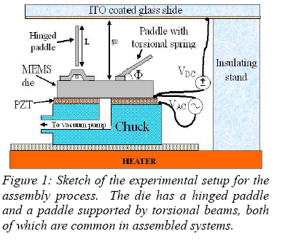
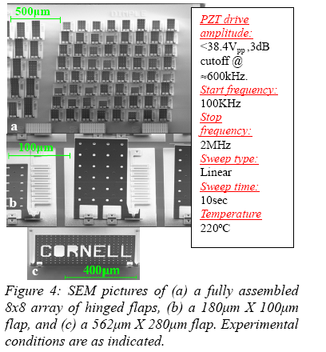

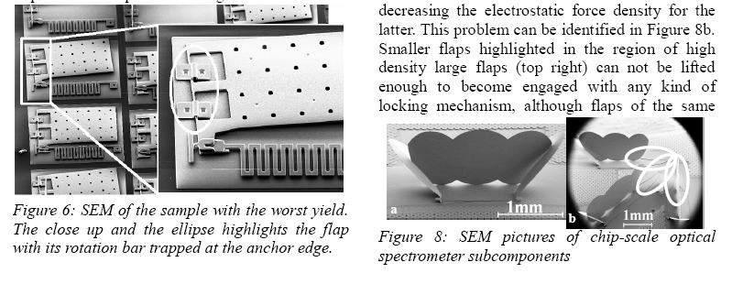

A WAFER TRANSFER TECHNOLOGY FOR INTEGRATION OF RF MEMS AND CMOS ON
ORGANIC SUBSTRATE
Q. X. Zhang, A. B. Yu, M. Tang, H.Y. Li, R.Yang, E.B. Liao, L. H. Guo, R. Kumar, A. Q.
Liu1, G. Q. Lo, N. Balasubramanian and D. L. Kwong
Institute of Microelectronics, 11 Science Park Road, Singapore
(Tel: +65-67705926; E-mail: qingxin@ime.a-star.edu.sg)
1School of Electrical & Electronic Engineering, Nanyang Technological University, Singapore
Abstract: A thermal bonding based wafer transfer technology was developed and successfully applied to
integrate RF MEMS switch and CMOS ICs on an organic substrate. The major process modules and
challenges in this transfer technology are discussed. By integrated together on the new substrate, the RFMEMS
switch illustrates significantly improved performance, and the CMOS show preserved
functionality. This technology demonstrates the feasibility and potential applicability of building high
performance, compact RF system for wireless communication.
Key words: RF MEMS, CMOS, integration, organic substrate, wafer transfer technology (WTT).
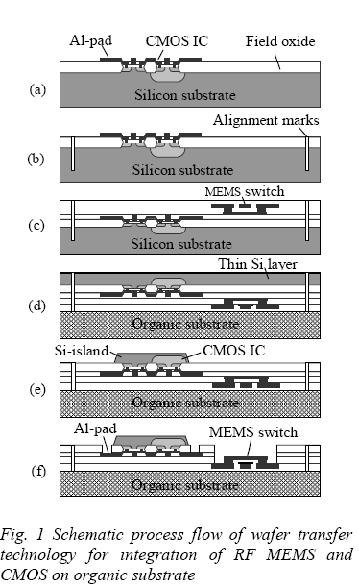
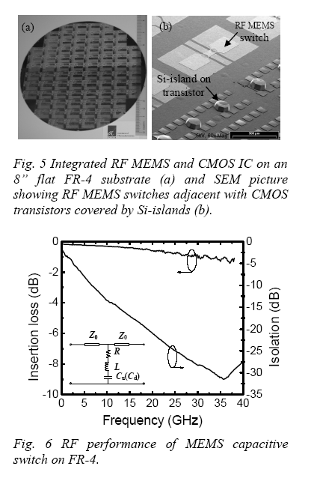

DRY FILMPACKAGE FOR SYSTEMIN PACKAGEMOLDING PROCESS
J.A.M. Sondag-Huethorst1, S. de Jager1, C. de Nooijer1, R.B.R. van Silfhout1, and M.H. van Kleef2
1Philips Applied Technologies, Eindhoven, The NETHERLANDS
(Tel: +31-40-2748756; E-mail: s.de.jager@philips.com)
2NXP Semiconductors, Nijmegen, The NETHERLANDS
(Tel: + 31-24-3536156; E-mail: marc.van.kleef@nxp.com)
Abstract: The stability of packages to protect a MEMS device against molding conditions is simulated
and experimentally verified. A Finite Element method is used to predict the displacement of the cover of
the package under influence of molding temperature and pressure. The model is verified using all organic
packages of two different materials: ConforMask of Rohm-Haas and TMMF of Tokyo Ohka Kogyo Co.
Ltd. The packages are made on wafer scale with a simple two layer dry film process. The process is
inexpensive and compatible with CMOS processing. The experimental results were in good agreement
with the modeling: the TMMF package (with relatively high Young modulus) withstands the molding
pressure.
Keywords: Dry film package, MEMS, molding, system-in-package (SIP)
