Quarter Status Report: EKV Winter 2003
Gus Mak

Introduction

The implementation of the EKV in verilog is continued from fall quarter 2002. Currently, there is still a bug in the transient response of our EKV model. The following sections describe what has been done this winter quarter to rid of the transient bug:

- Simulate Wladek’s sample verilog code for comparison
- Simulation of PMOS/NMOS inverter

The EKV model is currently coded in both Verilog and VHDL-AMS. However, they both show inconsistent results in the graphs attached at the end of this report. These graphs are from simulations of a resistor-transistor inverter circuit. Each graph corresponds to a different resistor that range from 1k to 5k. From figure 1.1 to 1.6, the resistor increases from 1k to 5k. The output of the circuit is somewhat consistent, but the output will not pull down to 0 when the input is “1”. At the 2.75k figure, the output voltage drops to a negative voltage.

1) Sample EKV Verilog code

The sample EKV code was simulated with the resistor-transistor inverter circuit. Figure 2.1-2.2 below shows the sample code simulated with a 2.5k and 10k resistor.

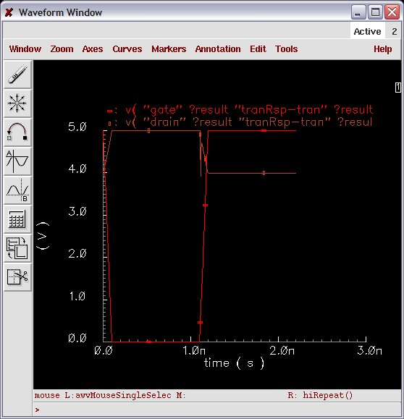
Figure 2.1 Sample EKV inverter with 2.5k resistor.

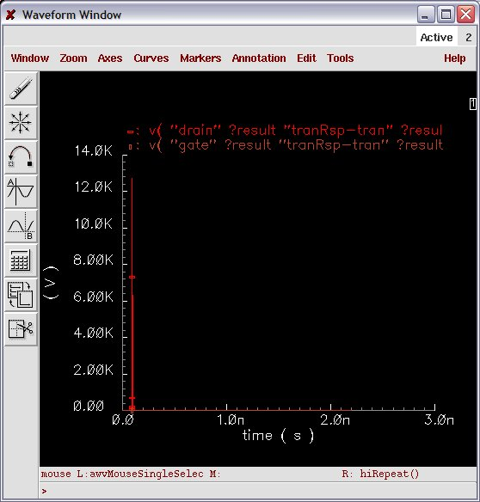
Figure 2.2 Sample EKV inverter 10k resistor.
Figure 2.3 and 2.4 below are simulations of our EKV model in the transistor inverter circuit with 2.5k and 10k resistor. Comparing our model to theirs show similar bugs.

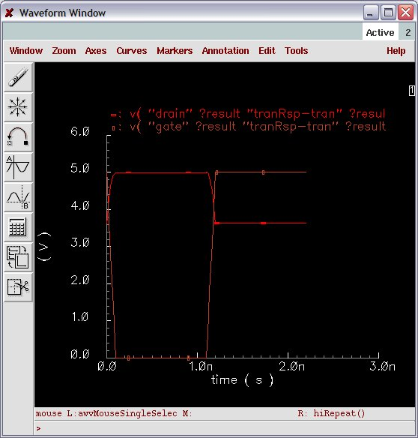
Figure 2.3 EKV model inverter with 2.5k resistor.

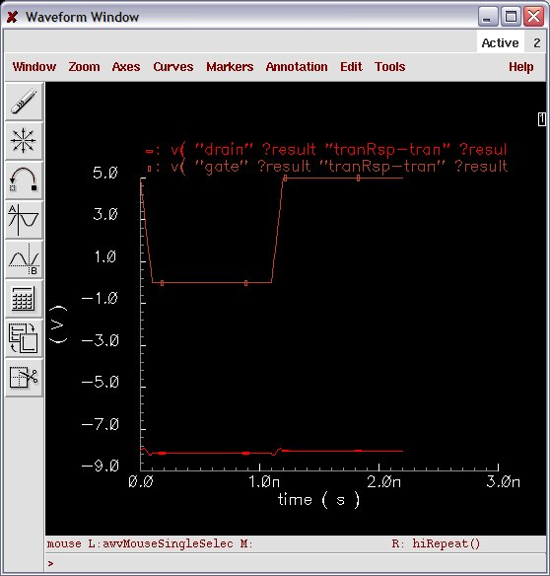
Figure 2.4 EKV model inverter with 10k resistor.

Both figures with 2.5k resistors are very similar, but output will not pull down to 0 when the input is a “1”. With the inverter resistor at 10k, our model’s output drops to a negative voltage, and the Sample model’s output shoots above 10k volts.

2) Simulation of PMOS/NMOS Inverter

Most of this quarter was devoted to specifically fixing the transient bug in the transistor-resistor inverter circuit, but I also tried to run an NMOS/PMOS inverter circuit. However, I get conversion difficulties errors and Figure 3.1 below illustrates what I got on my screen.

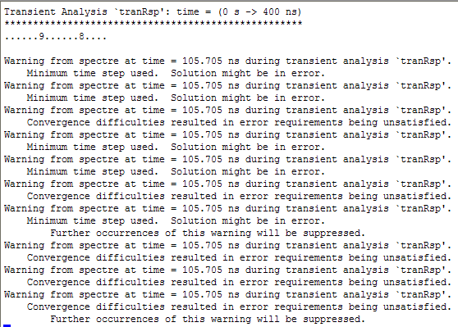
Figure 3.1 Simulation error of PMOS/NMOS inverter.

Current Work

Our EKV model shows the same transient bug compared to the Sample EKV model when the inverter circuit uses resistor values below 3K.

When using resistor values at 10k, our model’s output is negative and the Sample model’s output shoots above 10k volts.

Wladek has also sent me the C code for the EKV transistor. The following are two options that may be used to fix the transient bug:

- Transfer the C code from Wladek to Verilog and simulate again.
- Look up more references and try to modify the equations.

I am not sure how to start to debug the PMOS/NMOS inverter. I have recently tried to simulate this and will consult with Chris and Lily to find a solution. Chris and I are trying to fix the transient bug first.

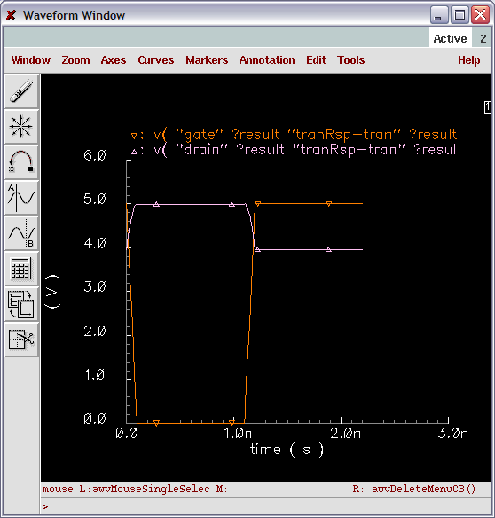
Figure 1.1 Inverter circuit with a 1kΩ resistor.

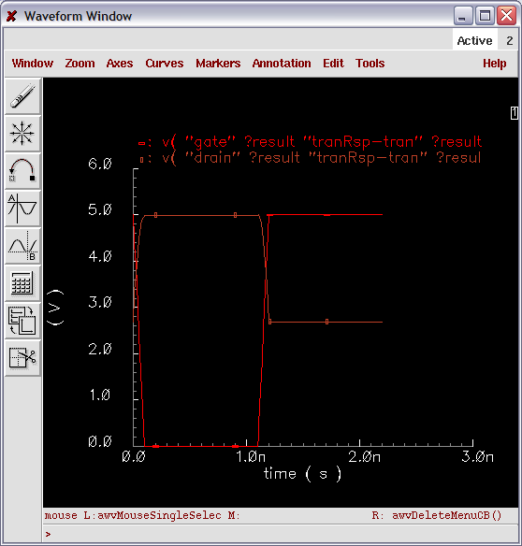
Figure 1.2 Inverter circuit with a 2kΩ resistor.
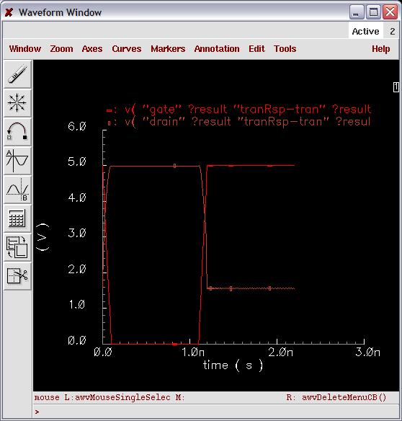
Figure 1.3 Inverter circuit with a 2.5kΩ resistor.

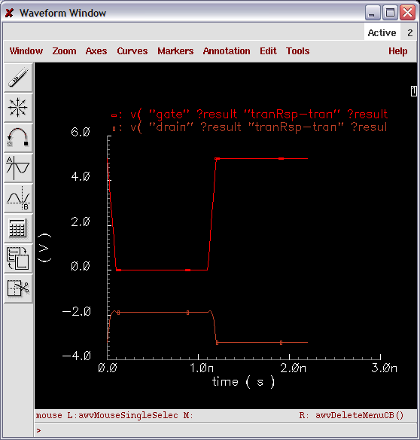
Figure 1.4 Inverter circuit with a 2.75kΩ resistor.

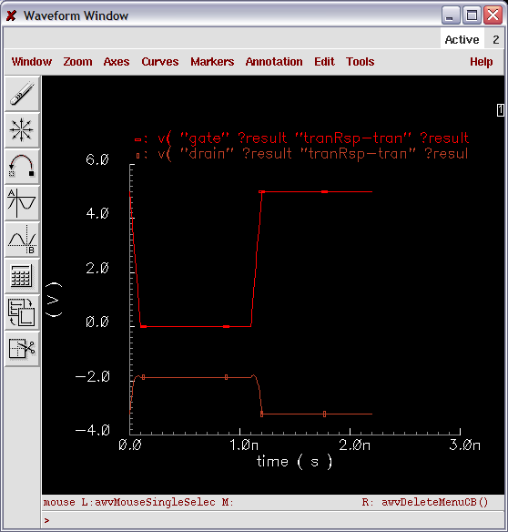
Figure 1.5 Inverter circuit with a 3kΩ resistor.

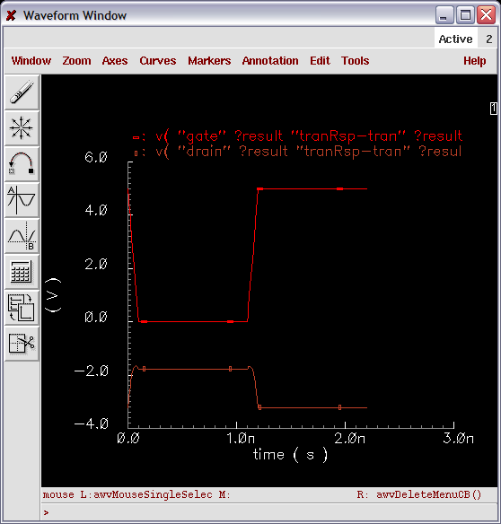
Figure 1.6 Inverter circuit with a 5kΩ resistor.

