IEEE P802.11
Wireless LANs
Simulation Results for SEEMesh Congestion Control Protocol
Date: 2005-06-10
Author(s):
Name | Company | Address | Phone | email
Akira Yamada | NTT DoCoMo, Inc | 3-5, Hikarino-oka, Yokosuka-shi, Kanagawa, Japan | +81-46-840-6527 | yamadaakir@nttdocomo.co.jp
Atsushi Fujiwara | NTT DoCoMo, Inc | 3-5, Hikarino-oka, Yokosuka-shi, Kanagawa, Japan | +81-46-840-3477 | atsushi@mlab.yrp.nttdocomo.co.jp
Bahareh Sadeghi | Intel Corp. | 2111 NE 25th Ave, JF3-206 Hillsboro, OR 97124 | +1-503-217-8367 | Bahareh.sadeghi@intel.com
Lily Yang | Intel Corp. | 2111 NE 25th Ave, JF3-206 Hillsboro, OR 97124 | +1-503-264-8813 | Lily.l.yang@intel.com
Abstract
This document provides preliminary simulation results illustrating the effect of implementing congestion control as described in SEEMesh proposal in mesh networks. The document first describes the simulation scenario and parameters used. It then compares the throughput of the system in a linear topology with and without congestion control. It shows how dynamically changing EDCA parameters in a simple back-pressure based congestion control scheme results in efficient utilization of the resources in a multi-hop network. Finally results are shown on transient performance of the congestion control scheme in a simple scenario.

Notice: This document has been prepared to assist IEEE 802.11. It is offered as a basis for discussion and is not binding on the contributing individual(s) or organization(s). The material in this document is subject to change in form and content after further study. The contributor(s) reserve(s) the right to add, amend or withdraw material contained herein.

Release: The contributor grants a free, irrevocable license to the IEEE to incorporate material contained in this contribution, and any modifications thereof, in the creation of an IEEE Standards publication; to copyright in the IEEE’s name any IEEE Standards publication even though it may include portions of this contribution; and at the IEEE’s sole discretion to permit others to reproduce in whole or in part the resulting IEEE Standards publication. The contributor also acknowledges and accepts that this contribution may be made public by IEEE 802.11.

Patent Policy and Procedures: The contributor is familiar with the IEEE 802 Patent Policy and Procedures <http:// ieee802.org/guides/bylaws/sb-bylaws.pdf>, including the statement "IEEE standards may include the known use of patent(s), including patent applications, provided the IEEE receives assurance from the patent holder or applicant with respect to patents essential for compliance with both mandatory and optional portions of the standard." Early disclosure to the Working Group of patent information that might be relevant to the standard is essential to reduce the possibility for delays in the development process and increase the likelihood that the draft publication will be approved for publication. Please notify the Chair <stuart.kerry@philips.com> as early as possible, in written or electronic form, if patented technology (or technology under patent application) might be incorporated into a draft standard being developed within the IEEE 802.11 Working Group. If you have questions, contact the IEEE Patent Committee Administrator at <patcom@ieee.org>.

1. Simulation Setup
The simulation environment used is OPNET, where the congestion control scheme has been implemented as a layer 2 mechanism. The results shown here are based on a congestion control scheme where each node measures its outgoing traffic rate and compares it with the incoming rate. If the incoming rate is bigger than the outgoing rate, the node is considered congested and it would send “Congestion Control Request” message to its upper stream neighbors with a more conservative target data rate so that the upper stream node can slow donw its transmission by increasing the AIFSN parameter by one. Otherwise if channel utilization over a link is below a given threshold, the link is considered under utilized, and the node would notify its upper stream node by sending “Congestion Control Request” (defined in [1]) message with a more aggressive target data rate so that the upper stream node can increase its transmission by decreases its AIFSN. Note that the AIFSN value is bounded by certain upper and lower thresholds.

2. Simulation Results: Throughput
Consider the topology depicted in Figure 1, where the network consists of 6 mesh points, with 2 flows: Flow 1 from Node 0 to Node 5, and Flow 2 from Node 5 to Node 0. Both flows have CBR traffic, with rate of 1.8 Mbps and 2.4 Mbps, respectively. In this scenario, only the immediate neighboring nodes are within transmission range of one another and the transmission rate on the link between any two nodes is assumed to be 11Mbps.

N_0

N_1
N_2
N_3
N_4
N_5
Flow 1
Flow 2
Figure 1. A chain topology of a multi-hop mesh network

Figure 2.a and 2.b depict the throughput per link with and without congestion control scheme for Flow 1 and Flow 2, respectively. Without use of congestion control in the system, each source tries to inject as many packets as possible into the network. Similarly, the relay nodes will also try to transmit and forward as many packets as possible. As a result, the high congestion results in reduced throughput per link as the flow progresses through the network. A congestion control scheme, however, measures the capability of each node in forwarding the traffic and regulates the upstream nodes traffic to that amount. As a result the network is injected by as many packets as it can handle servicing. As a result, in this specific example the end-to-end throughput is very close to what the traffic rate is.

a. Flow 1
b. Flow 2
Figure 2. Link by link throughput comparison with and without congestion control.

3. Simulation Results: Transient Performance
In this subsection we study the instantaneous throughput of two two-hop flows in the scenario depicted in Figure 3 when congestion control is being used.

Node 0
Node 1
Node 2
Forward flow
Reverse flow
Figure 3. Scenario with two multi-hop flows.

Both forward and reverse flows are saturated during their lifetime. The lifetime of the reverse flow is set to be 10 sec since beginning of the simulation. The forward flow, however, has traffic during the entire simulation duration.

Figure 4.a and 4.b show the throughput of the forward flow and the reverse flow respectively over time. As depicted in Figure 4.b the reverse traffic is terminated at t=10seconds. At the very beginning (t=0), it is clear that the blue links in both Figure 4.a and 4.b (which are the first hop for the two flows) start off with higher link throughput than the red links (which are the second hop for both flows). However, within the next 3 seconds, the congestion control takes effect and for both flows, the blue and red links gradually converge to roughly same link throughput with very small amount of fluctuation. At t=10, Figure 4.b shows 0 throughput because the reverse flow is terminated. It is interesting to point out that the forward flow as shown in Figure 4.a was able to utilize the excess bandwidth after t=10 because the Congestion Control Request message allows the node to inform its upper stream neighbors of a more aggressive target data rate if it detects low channel utilization locally due to circumstances like this. So as the reverse traffic is terminated, the congestion control mechanism realizes the existence of excess bandwidth and allows the amount of the traffic injected to the network to be increased until it matches the available resources. Note the red spike at t=10 is due to the packets in the buffer of Node 1 being emptied out quickly.

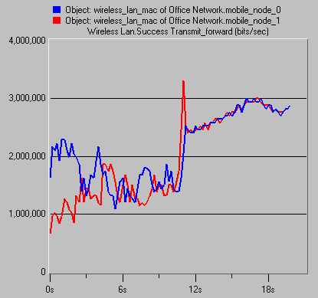

a. Forward flow
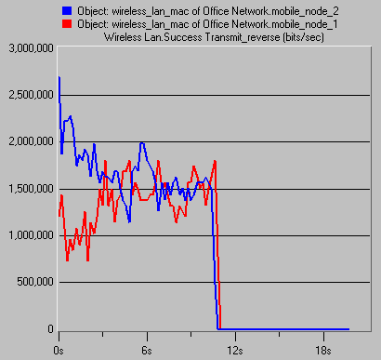
b. Reverse Flow

Figure 4. Instantaneous throughput result for the scenario of Figure 3.

It is worthwhile to point out that because a very conservative local rate control is used (by increasing or decresing AIFSN by 1 at a time), the convergence shown in Figure 4 is somewhat slow. By using a more aggressive local rate control mechanism (e.g., doubling CWmin), much shorter convergence time is expected. However, the more conservative the local rate control mechanism is, the more stable the network will be. Hence, in defining the rate control mechanism, one should find the right operating point considering the trade-off between fast convergence and system stability, which is a classical control system problem.

4. Summary
In this document we studied the performance of the congestion control mechanism proposed in SEEMesh proposal through OPNET simulations. The simulation scenarios used was multi-hop linear topologies with two flows. We showed that the overall end-to-end throughput is much higher with the use of congestion control in the system. We also showed how the proposed congestion control algorithm is capable of realizing the existence of excess resources in the system and utilizing them while maintaining the control on the amount of data injected to the network.

Appendix
Unless otherwise mentioned in the text the following simulation parameters were used to produce the results presented in this document:

Parameters |  | Description
General Simulation Parameters | Simulation Program | OPNET ver.10.5
General Simulation Parameters | Data PHY Speed | IEEE802.11b 11 Mbit/s
General Simulation Parameters | Ctrl PHY Speed | 1 Mbit/s
General Simulation Parameters | Mgmnt PHY Speed | 1 Mbit/s
General Simulation Parameters | Transmission range | Only neighboring nodes
General Simulation Parameters | Interference Range | < 2* Transmission range
General Simulation Parameters | Simulation Duration | 60 seconds
Traffic Models | Packet Size | 1500 Bytes
Traffic Models | Applied Traffic | CBR with 1.8 Mbit/s, 2.4 Mbit/s  at both ends
MAC Parameters | Retry Limit | 7
MAC Parameters | Buffer Size | 100 Packets
MAC Parameters | CWmin | 31
MAC Parameters | CWmax | 1023
MAC Parameters | AIFSN | 2
MAC Parameters | TXOP Limit | 0
Congestion Control Parameters | Peak Data Rate | Successful transmission rate to downstream
Congestion Control Parameters | Rate Control Method | Increment / Decrement AIFSN
Congestion Control Parameters | Congestion Control Request Transmission Rate | 1 packet / sec
Congestion Control Parameters | Traffic observation window | 1 sec
Congestion Control Parameters | Expiration Timer | 1 sec

References:
[1] IEEE 802 11-05/562r0, 802.11 TGs Simple Efficient Extensible Mesh (SEE-Mesh) Proposal

