IEEE P802.11
Wireless LANs

TGs Selection Procedure Recommendation

Name | Company | Phone | Email
Tricci So | Nortel Networks | +613-763-5915 | tso@nortelnetworks.com
Guido R. Hiertz | ComNets, Aachen University | +49-241-80-25-82-9 | hiertz@ieee.org
Juan Carlos Zuniga | InterDigital | +514-904-6251 | JuanCarlos.Zuniga@interdigital.com
Malik Audeh | Sony Corporation | +1-408-331-6834 | audeh@tropos.com
W. Steven Conner | Intel Corporation | +(503) 264-8036 | w.steven.conner@intel.com

Abstract

This document contains a draft recommendation for the selection procedure that will be followed by the IEEE 802.11s Task Group (this version is intended for discussion purpose on the September 16, 2004, Thursday session).

TGs Etiquette

All TGs members must respect all opinions during the discussion of the proposals and be open minded to work with others to enhance proposals via mergers according to the best technical solutions.

Changes of the Procedure

The task group reserves the right to change the selection process and selection criteria as required with a 75% approval.
Definitions

Functional Requirements – A list of mandatory and optional features of the amendment. These requirements shall be consistent with the PAR, the 5 Criteria and the Usage Models (document 11-04/662r10?). The Functional Requirements document shall contain a template that defines the format that presenters shall use to declare compliance with the requirements.

Comparison Criteria – A list of metrics and their definitions by which proposals shall be compared. The Comparison Criteria document shall contain a template that defines the format that presenters shall use to state their responses.
Proposal – A proposal that does not violate the PAR. All proposals shall disclose which Functional Requirements and Comparison Criteria they meet and how they meet them. This disclosure shall be done using the format required in the Functional Requirements and Comparison Criteria documents.

In the event of a conflict between the text and Annex A, the text will govern.

Steps of the Procedure

- TGs shall adopt Usage Models for the IEEE 802.11s amendment.
- TGs shall adopt the Scope Document as a supplement to the PAR.
- TGs shall adopt Functional Requirements that must be met by all proposals.
- TGs shall adopt Comparison Criteria that should be addressed by all proposals.
Note-1: Steps 1 thru 4 may occur in parallel. Reference the flow chart in Annex A for clarification.
Note-2: The documents generated in steps 1 thru 4 are intended to provide additional guidelines for TGs proposal selection, but are not anticipated to be as detailed as the document generated by the TGn.
- TGs shall issue a call for proposals.
- Proposals shall be given sufficient amount of presentation time including discussion as requested by the presenters, up to the maximum amount of time agreed by the TGs for all proposals. All proposal documents and related material (Presentation Material, Functional Requirements Declaration, Comparison Criteria Declaration and Technical Specification) emerging from the TGs call for proposals shall be available to the voting members 60 days prior to the session at which they will be presented. Any mergers resulting from the initial proposals shall be made available to the voting members at least 10 days prior to the session at which they will be presented. Merged proposals shall also include documents and related material.
- Immediately after the proposals are heard a Panel Discussion with all the presenters shall be held. Questions to the Panel shall be taken from the floor.

- Presenters of each proposal must be given the opportunity to make a final 5 minute statement to the group advocating their proposals just before the down selection voting starts. An elimination vote shall then be taken to remove proposals having little support within the task group. Each voting member shall cast a single ballot and vote to further consider or not to consider each individual proposal. The task group shall eliminate from consideration all proposals that do not obtain at least T.B.D.% support of the ballots cast.

In the sample ballot shown below, a single registered voter has voted for Proposals A, B, and C to continue to be under consideration and Proposals D and E to no longer be under consideration.

Voting Members Name: John Smith
VOTE TYPE | PROPOSAL A | PROPOSAL B | PROPOSAL C | PROPOSAL D | PROPOSAL E
CONSIDER | √ | √ | √
NOT CONSIDER |  |  |  | √ | √
Note: One vote per column per voter is required for a valid ballot.

- After any voting that eliminates proposals , the remaining proposals may undergo technical changes and merge with other proposals.
- The remaining candidates will again be given sufficient time to present new data related to their proposals and to answer any additional questions.

- Rounds of voting will be held that successively eliminate half of the candidate proposals until a maximum of four proposals are left (i.e. binary down selection process to expedite the decision making). In the case of a tie, the group shall vote using the binary selection process to get a single winner out of the tied proposals. If a merger occurs or if technical changes are made to a proposal, all presenters shall have the opportunity to present the details of their proposal again
- When N proposals are left, where 2 <= N <= 4, the process of elimination is one proposal at a time.
- To get to the next round of process, the left over proposals must meet all mandatory functional requirements. Otherwise, the proposal cannot be considered unless it is merged with other proposals to meet all mandatory functional requirements and to repeat the procedure of step 13.
- When one proposal is left, there shall be a confirmation roll call vote either in favor of the proposal or for none of the above. The proposal shall be required to achieve a 75% majority in order to be submitted to the IEEE 802.11s Editor as the initial technical specification. If the remaining proposal fails to achieve a 75% majority, the members who voted "no" shall be requested to provide to the chair their reason(s) for voting no and what would be required to change their vote to affirmative. The proposer shall have an opportunity to respond to the concerns of the no voters, after which a roll call vote will be taken to approve the proposal.
- If the last remaining proposal fails to receive 75% majority on the second roll call voting round, the process shall return to step 13 at the point where there were three proposals remaining or all proposals that initially entered step 13, if there were less than three. If two proposals decide to merge at this point or a proposal withdraws, the next previously eliminated proposal down will be added to provide a total of three proposals on the floor unless there were not three proposals that initially entered step 13.
- Having attained 75% support, the prevailing proposal will be adopted as the initial technical specification of IEEE 802.11s without further vote.
- The IEEE 802.11s Editor shall prepare Draft 1.0 from this technical specification. Draft 1.0 will then be put to a 75% vote in the task group to answer the question: “Is Draft 1.0 technically consistent with the initial technical specification?”

Aside: The editor will rely on technical experts likely to include the authors of the winning proposal to prepare this draft. The winning proposal's technical specification may be in a form that is acceptable (in the view of the editor) as an initial draft, in which case this step will be short. During the preparation of the initial draft, the editor may uncover technical inconsistencies, inaccuracies or omissions in the initial technical specification. The editor will present these technical issues to the task group to be debated and resolved.

Once Draft 1.0 has gained 75% support for the question, “Is Draft 1.0 consistent with the initial technical specification?", it will be forwarded to the working group for letter ballot without further vote in the IEEE 802.11s Task Group.

Annex A – TGs Down Selection Procedure Flow Chart

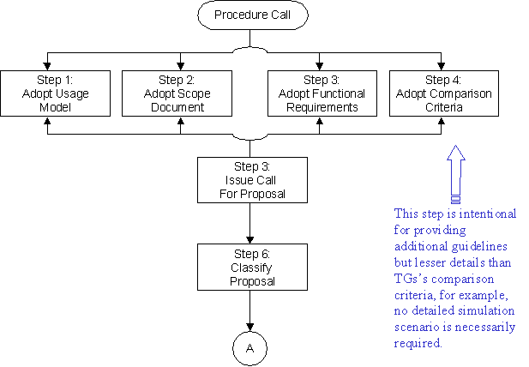

References

This selection procedure is adopted from the IEEE 802.11n Selection Procedure in document 11-03-0665r9 by Matthew Shoemake.

