IEEE P802.11
Wireless LANs
Draft Terms and Definitions for 802.11s
Date: August 23, 2004
Authors/Contributors:
Name | Company | Address | Phone/Fax | Email
Tricci So | Nortel Networks | 3500 Carling Ave., Ottawa ON K2H 8E9, Canada | +613-763-9639 | tso@nortelnetworks.com
Kevin Dick | Nortel Networks | P.O.Box 3511 Station C, Ottawa ON K1Y 4H7 Canada | +613-763-4366 | kdick@nortelnetworks.com
Jonathan Agre | Fujitsu Laboratories of America | 8400 Baltimore Ave., Suite 302, College Park, MD 20740, USA | +301-486-0978 | jagre@fla.fujitsu.com
W.Steven Conner | Intel Corporation | 2111 NE 25th Ave. Hillsboro, OR 97124 U.S.A. | +503-264-8036 | w.steven.conner@intel.com
Guido R. Hiertz | Aachen University | Kopernikusstr. 16 52064 Aachen Germany | +49-241-80-25-82-9 | hiertz@ieee.org
Donald E. Eastlake III | Motorola Laboratories | 111 Locke Dr., Marlboro, MA 01752, U.S.A. | +508-786-7554 | Donald.eastlake@motorola.com
Tyan-Shu Jou | Janusys Networks | 502 Lowell Ave., Palo Alto, CA 94301, U.S.A. | +919-656-2945 | tsjou@janusysnetworks.com
Ted Kuo | Janusys Networks | 502 Lowell Ave., Palo Alto, CA 94301, U.S.A. | +650-387-0589 | ted@janusysnetworks.com
Juan Carlos Zuniga | InterDigital Canada Ltd, | 1000 Sherbrooke W., 10th Fl., Montreal QC, H3A 3G4, Canada | +514-904-6251 | juanCarlos.zuniga@interdigital.com
Lily Yang | Intel Corporation | 2111 NE 25th Ave. Hillsboro, OR 97124 U.S.A. | +503-264-8813 | lily.l.yang@intel.com
Malik Audeh | Tropos Networks | 555 Del Rey Ave., Sunnyvale, CA 94085 | +408-331-6814 | audeh@tropos.com
Narasimha Chari | Tropos Networks | 555 Del Rey Ave., Sunnyvale, CA 94085 | +408-331-6814 | chari@tropos.com
Kazuyuki Sakoda | Sony Corporation | Oval Court Ohsaki MW 2-17-1 Higashigotanda Shinagawa-ku Tokyo 141-0022 Japan | +81-3-6409-3201 | sako@wcs.sony.co.jp
Hidenori Aoki | NTT DoCoMo. Inc | DoCoMo R&D Center, 3-5 Hikarino-oka, Yokosuka-shi, Kanagawa, 239-8536 Japan | +81-46-840-6526 | aokihid@nttdocomo.co.jp
Yoichi Matsumoto | NTT DoCoMo. Inc | DoCoMo R&D Center, 3-5 Hikarino-oka, Yokosuka-shi, Kanagawa, 239-8536 Japan | +81-46-840-3894 | matsumotoyou@nttdocomo.co.jp
Koji Omae | NTT DoCoMo. Inc | DoCoMo R&D Center, 3-5 Hikarino-oka, Yokosuka-shi, Kanagawa, 239-8536 Japan | +81-46-840-3890 | omae@mlab.yrp.nttdocomo.co.jp
Kue Wong | Nortel Networks | 3500 Carling Ave., Ottawa ON K2H 8E9, Canada | +613-763-2515 | jkwong@nortelnetworks.com
Vann Hasty | Mesh Networks | 485 N. Keller Rd.  Suite 250, Maitland, FL 32771 | +407-659-5371 | vhasty@meshnetworks.com
Sebnew Ozer | Mesh Networks | 485 N. Keller Rd.  Suite 250, Maitland, FL 32771 | +407-659-5391 | sozer@meshnetworks.com

Abstract

This draft document defines terms and terminology for 802.11 TGs.

Terminology and Definitions

Revision History
Revision | Comments | Date | Authors | Editor
R0 | Combined Core and Additional Terms & Definitions that were defined by ad-hoc team | August 23, 2004 | See above author list…. | Tricci So

Abstract
This document includes a collection of “core” and “additional” terms and definitions related to IEEE 802.11s that was agreed among the members of the ad-hoc team. The purpose of this document is to promote consistent use of new terminologies to describe 802.11s technology. The definitions in this document will eventually be integrated into the TGs amendment draft.

Issues
 | Issue | Status
1

Terminology and Definitions Document Organization
This document is arranged in the following organization:
- the “core” terms and definitions that are to be used to describe 802.11s core concepts
- the important “addition” terms and definitions that could be used to help to describe some generic system architecture

Introduction
This document includes a collection of terms and definitions related to IEEE 802.11s. The purpose of this document is to promote consistent use of new terminology to describe 802.11s technology. The definitions in this document will eventually be integrated into the TGs amendment draft.
The following two figures describe the concepts and a sample configuration of the core terms and definitions that are proposed by the ad-hoc team, respectively.
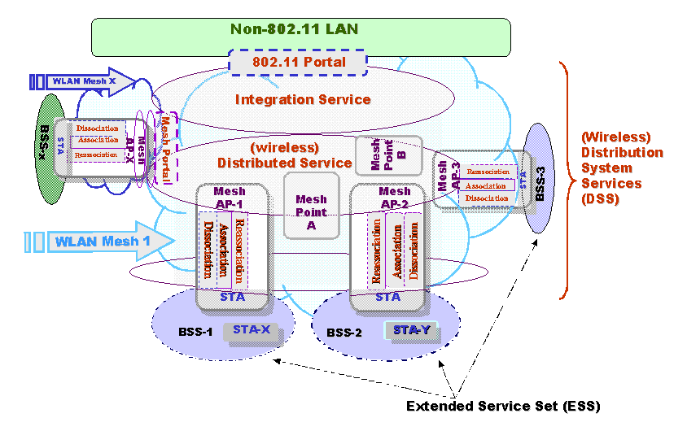
Figure 1: Proposed 802.11s Terminology Diagram

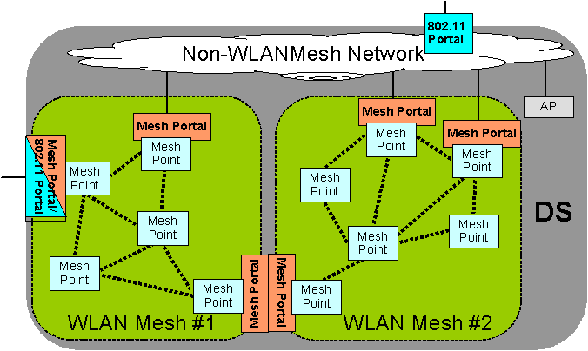
Figure 2: Example of the Mesh Portal Relationship with the WLAN Mesh and with the 802.11 Functional and Logical Components

Core Terms & Definitions
The following core terms are used to describe IEEE 802.11s basic concepts.

- WLAN Mesh – A WLAN Mesh is an IEEE 802.11-based WDS which is part of a DS, consisting of a set of two or more Mesh Points interconnected via IEEE 802.11 links and communicating via the WLAN Mesh Services. A WLAN Mesh may support zero or more entry points (Mesh Portals), automatic topology learning and dynamic path selection (including across multiple hops).
2. WLAN Mesh Services – The set of services provided by the WLAN Mesh that support the control, management, and operation of the WLAN Mesh, including the transport of MSDUs between Mesh Points within the WLAN Mesh. WLAN Mesh Services supplement DSS (Distribution System Services).
3. Mesh Point - Any IEEE 802.11 entity that contains an IEEE 802.11–conformant Medium Access Control (MAC) and Physical Layer (PHY) interface to the Wireless Medium (WM), is within a WLAN Mesh, and supports WLAN Mesh Services.
4. Mesh AP - Any Mesh Point that is also an Access Point.
5. Mesh Portal - A point at which MSDUs exit and enter a WLAN Mesh to and from other parts of a DS or to and from a non-802.11 network. A Mesh Portal can be collocated with an IEEE 802.11 portal.
6. Mesh Link - A direct IEEE 802.11 link between two Mesh Points.
7. Mesh Path - A concatenated set of connected Mesh Links from a source Mesh Point to a destination Mesh Point.
8. Mesh Path Selection – The process of selecting Mesh Paths.
9. Path Metric – Criteria used for Mesh Path Selection.
10. Mesh Topology – A graph consisting of the full set of Mesh Points and Mesh Links in a WLAN Mesh.
11. Mesh Neighbor - Any Mesh Point that is directly connected to another Mesh Point with a Mesh Link.
12. Mesh Unicast - Frame forwarding mechanism for transporting MSDUs to an individual Mesh Point within a WLAN Mesh.
13. Mesh Multicast - Frame forwarding mechanism for transporting MSDUs to a group of Mesh Points within a WLAN Mesh.
14. Mesh Broadcast - Frame forwarding mechanism for transporting MSDUs to all Mesh Points within a WLAN Mesh.

Supplementary Terms & Definitions
The following supplementary terms are used to provide more additional descriptions to TGs system architecture.

- Mesh Management Message – Message defined for managing and operating the mesh. The message is sent between Mesh Points. e.g., for path determination, neighbor discovery, topology discovery, etc. This definition of message is intended to be generic and does not specify the form of conveyor.
- Mesh Control Message - Message defined for controlling access to the WM used for communication among Mesh Points.
- Mesh Unicast Acknowledgment – An acknowledgement sent back from destination Mesh Point to source Mesh Point of a mesh path for a unicast message.
- Authenticated Mesh Point – A Mesh Point that has been authenticated as a valid participant in the WLAN Mesh. The authentication is with repect to a common policy determined by a single administrative entity.
- Mesh Identifier – A unique identifier for a WLAN Mesh.
- Mesh Discovery - A method to discover one or more WLAN Meshes.
- Mesh neighbourhood – A set of Mesh neighbours of a mesh point.
- Mesh Performance Metric – A criterion used to evaluate the performance of the Mesh.
- Mesh Link Metric – A criterion used to characterize the performance/quality/eligibility of a mesh link as a member of a mesh path. A mesh link metric may be used in a computation of a path metric.
- Connected Mesh – The status of the WLAN Mesh in which all Mesh Points that are participating members of a WLAN Mesh are reachable.
- Disconnected Mesh – The status of the WLAN Mesh in which a subset of Mesh Points that are participating members within the WLAN Mesh are not reachable. It is also called a partitioned Mesh.
- Mesh Association - The service used to establish the Mesh Point membership within a WLAN Mesh. Mesh association is independent from STA association to an AP.
- Mesh Member Set – The set of associated Mesh Points within a WLAN Mesh.
- Mesh Service Area - The conceptual area within members of a WLAN Mesh may communicate.
- Mesh Coordination Function (MCF) - A logical function used to coordinate access of the Mesh Points (MPs) on the WM. The MCF is used for communication among MPs.

References
Ref- 11-04-0730-03-000s-draft-core-terms-and-definitions-802.11s.doc
Ref- 11-04-0822-00-000s-802.11s-additional-core-terms-and-definitions.doc
Ref- 11-04-0785-01-000s-interpretations-dss-based-802-11-spec.ppt

