IEEE P802.11
Wireless LANs
Proposed 802.11 TGs Scope
Date: 16 August 2004
Authors:

Name | Company | Email | Contact Info
Tricci So | Nortel Networks | tso@nortelnetworks.com | 3500 Carling Ave., Ottawa, ON, K2H 8E9, Canada
Jonathan Agre | Fujitsu | jagre@fla.fujitsu.com
Ambatipudi Sastry | Packethop | sastry@packethop.com
Kazuyuki Sakoda | Sony | sako@wcs.sony.co.jp
Malik Audeh | Tropos Networks | malik@audeh@tropos.com
Narasimha Chari | Tropos Networks | chari@tropos.com
Vann Hastry | Mesh Networks | vhastry@meshnetworks.com
Sebnem Z. Ozer | Mesh Networks | sozer@meshnetworks.com
Juan Carlos Zuniga | Interdigital | Juancarlos.zuniga@interdigital.com
Stephan Rayment | BelAir Networks | srayment@belairnetworks.com
Lily Yang | Intel | Lily.l.yang@intel.com
W. Steven Conner | Intel | w.steven.conner@intel.com
Benoit Fremont | France Telecom | Benoit.Fremont@francetelecom.com
Veronique Bayle | France Telecom | Vero.bayle@francetelecom.com
Avinash Joshi | Mesh Networks | ajoshi@meshnetworks.com

Abstract
This document proposes the scope as one of the activities to be undertaken by 802.11 TGs ESS Mesh Network Architecture Framework Ad Hoc team.

Table of Contents

1 Document Version History 3
2 Working Notes and Issues 3
3 Introduction 3
4 TGs Process 3
5 802.11 TGs PAR Summary 4
5.1 Scope of Proposed Project 4
5.2 Purpose of Proposed Project 4
5.3 Additional Explanatory Notes 4
6 Key Highlevel Requirements Derived from PAR and Others 5
7 Areas of System Functions Derived from PAR 7
8 Proposed Scope Based on System Functional Areas for ESS Mesh Standard Development 8
8.1 Mesh WDS Service Integration 10
8.2 Mesh RF Resource Control and Management 10
8.3 Auto Wireless Link Discovery and Topology Learning 11
8.4 Mesh Network Performance and Measurement 11
8.5 Mesh Network Operation, Control and Management 12
8.6 WDS STA Mobility Support 12
8.7 Mesh Network and Service Interworking 13
8.8 Mesh Routing and Forwarding 13
8.9 Mesh Network Operation and Control 14
9 Conclusion 14
APPENDIX- A 15
A. 1 Key IEEE Standard Requirements Extracted from Five Criteria 15
A.1. 1 Compatibility 15
A.1. 2 Distinct Identity 15
A.1. 3 Technical Feasibility 15
A.1. 4 Economic Feasibility 15
A.1. 5 Marketing Requirments Considerations Based on Five Criteria 15

List of Figures

Figure 1: Scope Considerations by 802.11 TGs 7
Figure 2: Highlevel view on the System Functions Interactions 8
Figure 3: Key Functions in Functional Areas (part-1) 9
Figure 4: Key Functions in Functional Areas (part-2) 9

List of Tables

Table 1: Key Highlevel Technical Requirements from PAR and cross reference to Five Criteria 6
Table 2: Key Highlevel Technical Requirements NOT come from PAR 6
Table 3: Mandatory System Functional Areas According to TGs PAR 7
Table 4: Key Highlevel Marketing Requirements Considerations from Five Criteria 16

Document Version History

11-04-0xxx-00-000s-scope (mm/dd/yy)
- First draft document derived from IEEE 802.11 ESS Mesh PAR (11-04/054) and Five Criteria (11-04/056).
- Edited on 7/29/04 by J. Agre
- Edited on 8/1/04 by Tricci So to incorporate J. Agre’s inputs
- Edited on 8/10/04 by Tricci So to incorporate Steven Conner and ad-hoc group’s comments on 8/9/04
- Edited on 8/16/04 by Tricci So to incorporate additional comments from Steven Conner and to rearrange section 8.

Working Notes and Issues

[Editor Note: To Be Updated.]

Introduction

This document defines the scope of the efforts undertaken by TGs. It indicates which aspects of standards develop are or are not considered by the TGs effort as follows:
- In-scope – aspects that will be considered, addressed, or affected by TGs
- Out-of-scope – aspects that will not be considered or addressed by TGs
- Unaffected – aspects that may co-exist with TGs, but will be unaffected, or essentially preserved, by TGs
- To-be-determined – aspects which are, as yet, TBD (to-be-determined) with respect to TGs

This document does not define the requirements for TGs, it only indicates which aspects of standards developed will, or will not, be addressed in the TGs requirements document and subsequent TGs documents.

This document is a living document that presents a “best estimate” proposal for the scope of TGs, but which will also evolve and be updated as the TGs effort progresses.

TGs Process

The generic Task Group process of getting to Letter Ballot in IEEE are as follows (11-04/800r3):
- Adoption of PAR and 5 Criteria
- Technical Presentations and Discussions
- Specify Any Additional Requirements and Comparison Criteria
- Call For Proposals
- Select/Combine from Submitted Complete/Partial Proposals to Produce a Draft
- Refine Draft
- Letter Ballot

Currently, the following process has been used based on the discussion in TGs in July04 Meeting (11-04/800r3):
- Ad Hoc Subgroups
  - Have no special status unless TGs votes on them or their output
  - Any group of 802.11 members can get together and make submissions
- Within the Policies and Procedures (11-04/510r0), TGs can do what TGs want internally:
  - “Adopted” internal TGs motions/documents can be amended by majority with notice (i.e. if change is on agenda) or 2/3 vote without notice.
  - TGs can issue a call for proposals
    - With no requirements other than the PAR & 5 Criteria
    - With some guidelines
    - With detailed requirements
  - We can have “Functional Requirements Document” that is as general or specific as TGs like.

The intent of this document is to propose the following process to develop the draft specification to submit for the Letter Ballot.

The most important objectives of this document are to:
- Clarify the scope and the set of system functions that are based on the PAR of the 802.11 ESS Mesh
- Agree on the interpretation of the PAR and five criteria, and define the list of functional requirements that are within the scope of development

Once the common understanding on the scope is established among the TGs members, the network architecture ad-hoc group should then work together with TGs members to:,
- Identify a mesh-end to mesh-end network architecture which is based on the usage models and network deployment scenarios to define the functional requirements that are within the scope
- Define the Timeline and Milestones and Deliverables
- Define the set of Selection Criteria on proposals
- Define the set of PICs Areas to verify the feasibility of final recommendations

The results of these activities should produce the following set of documents from this ad-hoc team:
- High-level TGs Network Architecture Framework and Reference Model
- Comparision and Selection Criteria on TGs proposals
- PICs Areas

Just as important as it is for the TGs to agree on the scope, it is necessary for TGs to clarify and to agree on the set of system functions that are considered as Out-of-scope, Unaffected and To-be-determined so that the members of the TGs can focus to develop proposals that will be evaluated based on the same set of criteria.

802.11 TGs PAR Summary

Scope of Proposed Project

To develop an IEEE 802.11 Extended Service Set (ESS) Mesh* with an IEEE 802.11 Wireless Distribution System (WDS) using the IEEE 802.11 MAC/PHY layers that supports both broadcast/multicast and unicast delivery over self-configuring multi-hop topologies.

Purpose of Proposed Project

The IEEE 802.11-1999 (2003 edition) standard provides a four-address frame format for exchanging data packets between APs for the purpose of creating a Wireless Distribution System (WDS), but does not define how to configure or use a WDS. The purpose of the project is to provide a protocol for auto-configuring paths between APs over self-configuring multi-hop topologies in a WDS to support both broadcast/multicast and unicast traffic in an ESS Mesh using the four-address frame format or extensions.

Additional Explanatory Notes

Scope of the Project: An IEEE 802.11 Extended Sevice Set (ESS) Mesh* is a collection of APs interconnected with wireless links that enable automatic topology learning and dynamic path configuration.

The proposed amendment shall be an extension to the IEEE 802.11 MAC. The amendment will define an architecture and protocol for providing an IEEE 802.11 ESS Mesh using the IEEE 802.11 MAC to create an IEEE 802.11 Wireless Distribution System that supports both broadcast/multicast and unicast delivery at the MAC layer using radio-aware metrics over self-configuring multi-hop topologies. An ESS Mesh is functionally equivalent to a wired ESS, with respect to the STAs relationship with the BSS and ESS.

The amendment shall enable interoperable formation and operation of an ESS Mesh, but shall be extensible to allow for alternative path selection metrics and/or protocols based on application requirements. A target configuration is up to 32 devices participating as AP forwarders in the ESS Mesh. However, larger configurations may also be contemplated by the standard. It is intended that the architecture defined by the amendment shall allow an ESS Mesh to interface with higher layers and to connect with other networks using higher layer protocols.

The amendment shall utilize IEEE 802.11i security mechanisms, or an extension thereof, for the purpose of securing an ESS Mesh in which all of the APs are controlled by a single logical administrative entity for security. The amendment shall allow the use of one or more IEEE 802.11 radios on each AP in the ESS Mesh.

Key Highlevel Requirements Derived from PAR and Others

The following table explains the key highlevel requirements of the TGs scope, in terms of technical and other considerations, that are derived from the IEEE 802.11 TGs PAR and also cross reference to the Five Criteria as well as to the 802.11 standards. The information of these tables are used as the basis to derive the key highlevel technical requirements of the scope that is used to develop the draft 802.11 amendments for ESS Mesh networking specification by TGs. The figure below is to capture the considerations of the scope that needs to be addressed by the TGs.

Key Highlevel Technical Requirements |  | PAR | 5 Criteria | Reference Details
T.1 | Compatibility with 802.11 Distribution System Service (DSS)  - An ESS Mesh is functionally equivalent to a wired ESS, with respect to the STAs relationship with the BSS and ESS. |  |  | - Refer to 6.2 Compatibility section in 11-04/056 (Five Criteria)  - Refer to 18. Additional Explanatory Notes section in 11-04/054 (PAR)
T.2 | Enable automatic topology learning and dynamic path configuration to support self-configuring multihop topology.  - The amendment shall be extensible to allow for alternative path selection metrics and/or protocols based on application requirements |  |  | - Refer to 18. Additional Explanatory Notes section in 11-04/054 (PAR)
T.3 | Radio-awareness metrics to support self-configuring topology discovery and multi-hop routing. |  |  | - Refer to 6.3.a Distinct Identity section in 11-04/056 (Five Criteria)  - Refer to 18. Additional Explanatory Notes section in 11-04/054 (PAR)
T.4 | Support broadcast/multicast and unicast delivery at the MAC layer to the end user via multi-hop forwarding |  |  | - Refer to 12. Scope of Proposed Project, 13. Purpose of the Proposed Project and 18. Additional Explanatory Notes sections in 11-04/054 (PAR)
T.5 | Addressing based on the use of the four-address frame format or an extension |  |  | - Refer to 6.3.a Distinct Identity section in 11-04/056 (Five Criteria)  - Refer to 13. Purpose of Proposed Project section in 11-04/054 (PAR)
T.6 | Interfacing with high layer protocols and interworking with other non-802.11 network using high layer protocols |  |  | - Refer to 18. Additional Explanatory Notes section in 11-04/054 (PAR).
T.7 | Security based on the use of existing 802.11i standard or an extension thereof, for the purpose of securing an ESS Mesh in which all of the APs are controlled by a single logical administrative entity for security. |  |  | - Refer to 18. Additional Explanatory Notes section in 11-04/054 (PAR).
T.8 | Support the use of one or more IEEE 802.11 radios on each AP in the ESS Mesh. |  |  | - Refer to 18. Additional Explanatory Notes section in 11-04/054 (PAR).
T.9 | ESS Mesh is an extension to the IEEE 802.11 MAC and does not require PHY changes |  |  | - Refer to 18. Additional Explanatory Notes section in 11-04/054 (PAR).
Table 1: Key Highlevel Technical Requirements from PAR and cross reference to Five Criteria

Key Highlevel Requirements Outside of PAR |  | Mandatory | Optional | Justification
O.1 | Task Group co-ordination to be addressed by TGs, i.e.  - 802.11r  - 802.11i  - 802.11e  - 802.11k  - 802.11n  - 802.11f  - others |  |  | - Ensure compatibility of all 802.11 standards with TGs
O.2 | Existing standards implications addressed by TGs, i.e.  - Recommended practices and/or modifications to existing base standards with respect to Mesh Services  - Identification of existing standards that are preserved/unaffected by TGs  - Identification of existing standards that TGs interoperates with |  |  | - Clarify the implications to all existing 802.11 standards, if any, due to TGs work
O.3 | Mesh Network STA Mobility Support |  |  | - Ensure the WDS infrastructure is compatible to the existing 802.11f IAPP, 802.11i Fast Roaming feature, and the work done in 802.11r Fast BSS Transition
O.4 | Support both the distributed and centralized network management models |  |  | - Consider the network management requirements to address the non-home networking products.

Table 2: Key Highlevel Technical Requirements NOT come from PAR

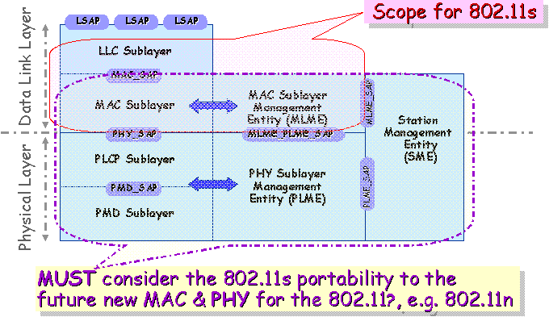
Figure 1: Scope Considerations by 802.11 TGs

Areas of System Functions Derived from PAR

Based on the highlevel requirements that were extracted from previous section, this following table summarizes the list of system functions that IEEE 802.11s ESS Mesh standard MUST address.

System Functional Areas |  | References to High Level Requirements based on Section 6
A.1 | 802.11 WDS services Integration | T.1. T.9
A.2 | Mesh RF Resource Control and Management | T.3, T.8
A.3 | Mesh Routing & Forwarding | T.2. T4. T.9
A.4 | Mesh Single Administrative Domain Base Network Security | T.7
A.5 | Mesh WDS STA Mobility Support  (NOTE: Need to distinguish the functions to support “roaming” vs. “handoff” for STA mobility management.) | O.3
A.6 | Mesh Network Performance and Measurement | T.9
A.7 | Mesh Service and Network Interworking | T.6
A.8 | Mesh Auto-discovery and topology learning | T.2, T.9
A.9 | Mesh Network Operational, and Control (e.g. network security) | O.4, T.5
Table 3: Mandatory System Functional Areas According to TGs PAR

[Editor Note: Based on what criteria that we should develop the optional System Functional Areas, e.g. QoS support? ]

The following figure captures the highlevel view of these system functions and their possible dependency and interactions.

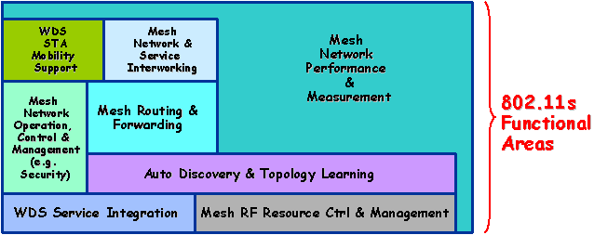
Figure 2: Highlevel view on the System Functions Interactions

Proposed Scope Based on System Functional Areas for ESS Mesh Standard Development

The following sections are to clarify the scope of the ESS Mesh standard development based on the system functional areas that were derived from the previous section. The architectural and system components are organized in term of their roles and definitions as described in the “Terms and Definitions” (see 11-04/0730r3 and 11-04/0822r1 for details) and their applicability to the scope and five criteria. Each of these components is examined with respect to its relative impact to the system functional areas that were discussed earlier. The results are captured in a form of table under the categories of
- In-scope
- Out-of-scope
- Un-affected
- To-be-determined

The following two figures summarize the key functions that need to be considered within each of these system functional areas:

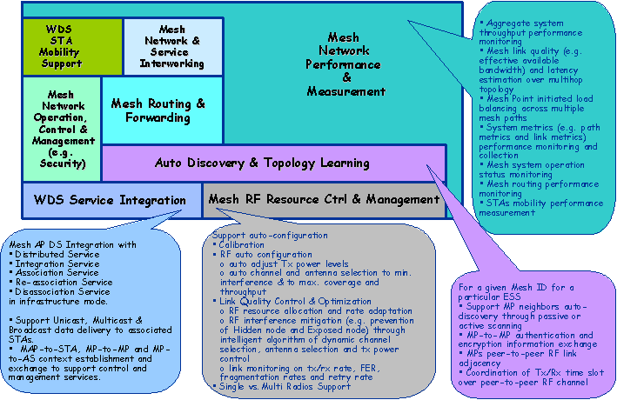

Figure 3: Key Functions in Functional Areas (part-1)

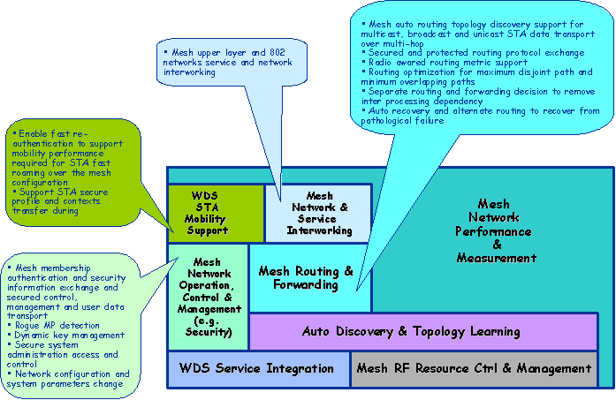
Figure 4: Key Functions in Functional Areas (part-2)

Mesh WDS Service Integration

The following captures the scope of 802.11 WDS service integration that may be addressed by TGs:

Component Applicability |  | Clarifications | System Functional Areas Mapping
In-scope
 | Mesh WDS Service  Integration | => Mesh Point DS Integration with existing 802.11 DS services  - Distributed Services  - Integration Services  - Association Services  - Re-association Services  - Disassociation Services  where the MAP is operating in infrastructure mode.  => Support Unicast, Multicast and Broadcast data delivery to associated STAs  => MAP-to-STA, MP-to-MP and MP-to-AS communications to support data, control and management traffic. | - Refer to system functional areas A.1
Unaffected
To-be-determined
Out-of-scope

Mesh RF Resource Control and Management

This section is to define the system functions that are designed to control and manage the RF resources and the 802.11 wireless link quality in a WLAN Mesh network .

Component Applicability |  | Clarifications | System Functional Areas Mapping
In-scope
 | Mesh RF Resource Control and Management | => Support MP auto-configuration for  - Calibration  - RF auto configuration  - Auto adjust Tx power levels  - Auto channel and antenna selection to minimize interference and to maximize coverage and throughput  - Link Quality Control & Optimization  - RF resource allocation and rate adaptation  - RF interference mitigation (e.g. prevention of Hidden Node and Exposed node problems) through intelligent algorithm to control channel, antenna and tx power  - Link monitoring on tx/rx rate, FER, fragmentation rates and retry rate  - Single vs. Multi Radios Support | - Refer to system functional areas A.2
Unaffected
To-be-determined
Out-of-scope

Auto Wireless Link Discovery and Topology Learning

This section is to discuss the system functions that are design to establish MPs peer-to-peer wireless link adjacency and integrity.

Component Applicability |  | Clarifications | System Functional Areas Mapping
In-scope
 | Auto Wireless Link Discovery and Topology Learning | => For a given WLAN Mesh with Mesh ID belongs to a particular ESS  - Enable MP neighbors auto-discovery through passive or active scanning  - MP-to-MP authentication and privacy information exchange  - MPs peer-to-peer RF link adjacency  - Coordination of Tx/Rx time slot over peer-to-peer RF channel alignment | - Refer to system functional areas A.3
Unaffected
To-be-determined
Out-of-scope

Mesh Network Performance and Measurement

This section is to discuss the essential system statistic that is required to collect to support system functions and to report system performance – e.g. routing metric, traffic management, fault management, operation status, control traffic overhead etc.

Component Applicability |  | Clarifications | System Functional Areas Mapping
In-scope
 | Mesh network performance and measurement | - Aggregate system throughput performance monitoring  - Mesh link quality (e.g. effect available bandwidth) and latency estimation over multihop topology  - MP initiated load balancing across multiple mesh paths  - System metrics (e.g. path metric and link metric) performance monitoring and collection  - Mesh system operation status monitoring  - Mesh routing and forwarding performance monitoring  - STAs mobility performance measurement | - Refer to system functional areas A.4
Unaffected
To-be-determined
Out-of-scope

Mesh Network Operation, Control and Management

This section is to discuss the system functions that are required to support the on-going system operation, control and management, e.g. IP addressing, MP mesh network membership, mesh network security etc.

Component Applicability |  | Clarifications | System Functional Areas Mapping
In-scope
 | Mesh network Operation, Control and Management | - MP mesh network membership authentication and secured mesh association support  - Secured user, control and management data transport over the wireless links.  - Rogue MP detection and reporting  - Dynamic key management  - Secured system administration access and control  - Network configuration and system parameters initialization and re-configuration | - Refer to system functional areas A.5
Unaffected
To-be-determined
Out-of-scope

WDS STA Mobility Support

This section is to define the system functions that are required to support STA mobility over the WLAN Mesh network.

Component Applicability |  | Clarifications | System Functional Areas Mapping
In-scope
 | WDS STA Mobility Support | - Fast context transfer to enable rapid STA re-authentication to support seamless handoff performance.  - Ensure encryption key synchronization between the MPs during the mobile handoff | - Refer to system functional areas A.6
Unaffected
To-be-determined
Out-of-scope

Mesh Network and Service Interworking

This section is to discuss the system functions and interfaces that support data transfer between the WLAN Meshes, and between the WLAN Mesh and a non-802.11 network at the MAC or upper layer through the support of the 802.11 Portal and Mesh Portal.

Component Applicability |  | Clarifications | System Functional Areas Mapping
In-scope
 | Mesh network and service interworking | - Functional clarification of the 802.11 portal  - Functional description of the interface of the Mesh portal  - Interworking functions that are required to transport the user, control and management traffic between 802.11 and non-802.11 networks. | - Refer to system functional areas A.7
Unaffected
To-be-determined
Out-of-scope

Mesh Routing and Forwarding

This section is to discuss the system functions and protocol requirements that are necessary for supporting auto network topology discovery and data forwarding over multihop.

Component Applicability |  | Clarifications | System Functional Areas Mapping
In-scope
 | Mesh Routing and Forwarding | - Mesh auto routing topology discovery support for multicast, broadcast and unicast data delivery to STA over multihop forwarding.  - Light weight and secured routing protocol exchange  - Radio awared routing metric support  - Routing optimization considerations to maximum RF resource utilization over the WLAN Mesh  - Separation of routing and forwarding decisions to get rid of inter processes dependency.  - Auto recovery and alternate routing to recover from nodal or link failure in the WLAN Mesh. | - Refer to system functional areas A.8
Unaffected
To-be-determined
Out-of-scope

Mesh Network Operation and Control

This section is to discuss the system functions and protocol requirements that are necessary for supporting system operation and control functions.

Component Applicability |  | Clarifications | System Functional Areas Mapping
In-scope
 | Mesh Network Operation and Control | - Security for mesh membership and system transport mechanism  - Rogue Mesh Point detection  - Dynamic key management  - Secure system administration access and control, if required  - Network configuration and system parameters update | - Refer to system functional areas A.9
Unaffected
To-be-determined
Out-of-scope

Conclusion

APPENDIX-

A. 1 Key IEEE Standard Requirements Extracted from Five Criteria

A.1. 1 Compatibility

IEEE 802 defines a family of standards. All standards shall be in conformance with the IEEE 802.1 Architecture, Management and Interworking documents as follows: 802. Overview and Architecture, 802.1D, 802.1Q and parts of 802.1f. If any variances in conformance emerge, they shall be thoroughly disclosed and reviewed with 802. Each standard in the IEEE 802 family of standards shall include a definition of managed objects, which are compatible with system management standards.

ESS Mesh specifies one possible Wireless Distribution System (WDS) that behaves in every respect as an IEEE 802.11 Infrastructure Mode network. As such, it is entirely compatible with the 802.11 architecture and, by inference, compatible with the IEEE 802 architecture, including IEEE 802.1D, IEEE 802.1Q and IEEE 802.1F.

[Editor Note: The definition of infrastructure according to IEEE 802.11 specification is as follows,
The” infrastructure” includes the distribution system medium (DSM), access point (AP), and portal entities. It is also the logical location of distribution and integration service functions of an extended service set (ESS). An infrastructure contains one or more APs and zero or more portals in addition to the distribution system (DS).]

A.1. 2 Distinct Identity

…Instantaneous radio-awareness is currently out-of-scope for IETF Mobile Ad Hoc Networks (MANET), limiting its ability to make efficient use of the wireless channel, unlike ESS Mesh which allows tight integration between the MAC and the multi-hop WDS.

…These design goals (i.e. of IEEE 802.11f) differ significantly from those of ESS Mesh which primarily concerns itself with topology discovery, delivery, and mobility management for a wireless DS implementation.

…IEEE 802.11 ESS Mesh is the only wireless distribution system (WDS) protocol defined in 802.11.

A.1. 3 Technical Feasibility

…Address mapping information enables roaming, i.e. the ability of the DS to determine the correct output point or points for user traffic, while global topology information is used to compute unicast paths.

A.1. 4 Economic Feasibility

…Considering the cost of IEEE 802.11 APs in the market place, it is a reasonable cost to add a wireless DS, especially in comparison to the cost of a wired DS.

…The proposed amendment has no known impact on installation costs.

A.1. 5 Marketing Requirments Considerations Based on Five Criteria

Key Highlevel Marketing Requirements |  | PAR | 5 Criteria | Reference Details
M.1 | Support an integrated subnet routing/mobility layer with the WLAN architecture |  |  | - Refer to 6.1.a Broad sets of applicability section in 11-04/056 (Five Criteria)
M.2 | Using ESS Mesh, coverage within a house, a hospital, a hotel, and airport, a neighbourhood, a campus, etc., may be extended wirelessly and without manual configuration other than setting the SSID and/or AP introduction. |  |  | - Refer to 6.1.a Broad sets of applicability section in 11-04/056 (Five Criteria)
M.3 | ESS Mesh improves the versatility and functionality of conventional WLAN APs by extending services wirelessly as an alternative or an addition to wired connections |  |  | - Refer to 6.1.c Broad sets of applicability section in 11-04/056 (Five Criteria)
M.4 | Considering the cost of IEEE 802.11 APs in the market place, it is a reasonable cost to add a wireless DS, especially in comparison to the cost of a wired DS. |  |  | - Refer to 6.5.b Economic Feasibility section in 11-04/056 (Five Criteria)
M.5 | The proposed amendment has no known impact on installation costs |  |  | - Refer to 6.5.c Economic Feasibility section in 11-04/056 (Five Criteria)
Table 4: Key Highlevel Marketing Requirements Considerations from Five Criteria

