IEEE P802.11
Wireless LANs
Usage Models

Date: July 12, 2004

Authors/Contributors:
Name | Company | Address | Phone | Fax | Email
W.Steven Conner | Intel Corporation | 2111 NE 25th Ave. Hillsboro, OR 97124 U.S.A. | +503-264-8036 |  | w.steven.conner@intel.com
Jonathan Agre | Fujitsu Laboratories of America | College Park, MD, U.S.A. | +301-486-0978 |  | jagre@fla.fujitsu.com
Hidenori Aoki | NTT DoCoMo Inc | DoCoMo R&D Center, 3-5 Hikarino-oka, Yokosuka-shi, Kanagawa, 239-8536 Japan | +81-46-840-6526 |  | aokihid@nttdocomo.co.jp
Malik Audeh | Tropos Networks | 555 Del Rey Ave., Sunnyvale, CA 94085 U.S.A. | +408-331-6814 |  | audeh@tropos.com
Narasimha Chari | Tropos Networks | 555 Del Rey Ave., Sunnyvale, CA 94085 U.S.A. | +408-331-6814 |  | chari@tropos.com
Kevin Dick | Nortel Networks | P.O.Box 3511 Station C, Ottawa ON K1Y 4H7 Canada | +613-763-4366 |  | kdick@nortelnetworks.com
Donald E. Eastlake III | Motorola Laboratories | 111 Locke Dr., Marlboro, MA 01752, U.S.A. | +508-786-7554 |  | Donald.eastlake@motorola.com
Jörg Habetha | Philips Research Laboratories | Weisshausstr. 2, D-52066 Aachen, Germany | +49-241-6003-560 |  | joerg.habetha@philips.com
Guido R. Hiertz | Aachen University | Kopernikusstr. 16 52064 Aachen Germany | +49-241-80-25-82-9 |  | hiertz@ieee.org
Tyan-Shu Jou | Janusys Networks, Inc. | 502 Lowell Ave., Palo Alto, CA 94301, U.S.A. | +919-0656-2945 |  | tsjou@janusysnetworks.com
Ted Kuo | Janusys Networks, Inc. | 502 Lowell Ave., Palo Alto, CA 94301, U.S.A. | +650-387-0589 |  | ted@janusysnetworks.com
Yoichi Matsumoto | NTT DoCoMo Inc | DoCoMo R&D Center, 3-5 Hikarino-oka, Yokosuka-shi, Kanagawa, 239-8536 Japan | +81-46-840-3894 |  | matsumotoyou@nttdocomo.co.jp
Koji Omae | NTT DoCoMo Inc | DoCoMo R&D Center, 3-5 Hikarino-oka, Yokosuka-shi, Kanagawa, 239-8536 Japan | +81-46-840-3890 |  | omae@mlab.yrp.nttdocomo.co.jp
Kazuyuki Sakoda | Sony Corporation | Oval Court Ohsaki MW 2-17-1 Higashigotanda Shinagawa-ku Tokyo 141-0022 Japan | +81-3-6409-3201 |  | sako@wcs.sony.co.jp
Tricci So | Nortel Networks | 3500 Carling Ave., Ottawa ON K2H 8E9, Canada | +613-763-9639 |  | tso@nortelnetworks.com
Jin Kue Wong | Nortel Networks | P.O. Box 3511 Station C, Ottawa, ON K1Y 4H7, Canada | +613-763-2515 |  | jkwong@nortelnetworks.com
Other contributors to be added (with permission)

Abstract

This document defines usage models for 802.11 TGs, intended to be used to define the functional requirements for 802.11s Mesh Networking and to specify well-defined simulation scenarios.

Revision History

Revision | Comments | Date | Author
R0 | Initial draft based on TGn Usage Models document 11-03-0802r16 | May 21, 2004 | SC
R1 | Edits and additions from ad-hoc group comments | May 30, 2004 | SC + contributions from adhoc group
R2 | Added additional notes on purpose of applications and use cases and more detailed instructions for filling out usage model template. | June 4, 2004 | SC
R3 | Edits based on feedback and new integrated contributions  - reorganized usage model section with two tables, one for high level descriptions and topologies and the other for collecting more detailed characteristics  - integrated all usage model examples, modifications, and comments received to-date  - started abbreviations and acronyms table for completeness  - added clarifying description text to applications and usage model sections  - renumbered applications, removing skipped numbers  - added additional example applications and use cases | June 17, 2004 | SC + contributions from adhoc group
R4 | Integrated new usage model contributions  - Public Safety/First Responder Community Network  - Residential Access Community Network  - Parade or Temporary Event | June 18, 2004 | SC + contributions from adhoc group
R5 | Integrated additional usage model description text and sample topologies | June 25, 2004 | SC + contributions from adhoc group
R6 | Integrated additional usage model examples and list of contributing authors. | July 9, 2004 | SC + contributions from adhoc group
R7 | Updates from discussion in face-to-face ad-hoc group meeting on Monday morning, July 12, in Portland, OR. | July 12, 2004 | SC, and ad-hoc group

Introduction
To support the definition of the 802.11 ESS Mesh WLAN standard within the IEEE (to be published eventually as the 802.11s amendment), this document attempts to define usage models based on various market-based use-cases. The usage models are intended to support the definitions of network simulations that will allow 802.11 TGs to evaluate qualitative requirements such as deployment characteristics and quantitative requirements such as the performance of various proposals in terms of, for example, network throughput, delay, packet loss and other metrics. It is anticipated that the outputs of this document will aid in the subsequent development of the evaluation and selection criteria used by TGs.

Note - These usage models that the usage model committee develops here are subject to the following constraints :
C1: They are relevant to the expected uses of the technology
C2: They pose a specific problem that can be addressed with 802.11 ESS mesh technology
C3: They are capable of being turned into an unambiguous simulation scenario

Process going forward
The following is a suggested process for developing usage model descriptions for TGs that will provide a useful foundation for defining specific functional requirements, simulation scenarios, and evaluation criteria for 802.11s proposals.

- A usage model description template will be created to allow volunteers to describe different usage models in a consistent, comparable fashion.
- Volunteers will fill in the template with descriptions of different usage models of interest for TGs, including sample deployment topologies for each usage model. These usage models will be organized in a small number of usage model categories, allowing similar usage models to be grouped together.
- For each category, a small sub-team of volunteers interested in the category will be formed to:
  - Refine usage model descriptions within each category
  - Merge similar usage models within each category
  - Develop initial requirements based on usage each usage model category (Qualitative and Quantitative Requirements)
- Usage models and initial requirements will then be prioritized, for example using one or more of the following criteria:
  - Scope of TGs from the PAR
  - Identified major outliers
  - Technology limitations
  - Voting
- Detailed functional requirements, representative simulation scenarios, and evaluation criteria for 802.11s will then be generated for high priority usage models.

This process is summarized in Figure 1.

Figure 1 – Possible Process for Using Usage Model Descriptions as Foundation for Detailed Requirements and Evaluation Criteria.

Definitions
This section defines some of the terms used in this document.

Application – a source or sink of wireless data that relates to a particular type of user activity.
Examples: Streaming video. VOIP.

Environment – The type of place a WLAN system is deployed in. Initial examples: home, large office.

Use case – A use case is a description of how an end user uses a system that exercises that system’s deployment of WLAN. A use case includes an application with details regarding the user activity and both sides of the end-to-end link.

Usage Model – A specification of one or more applications and environments from which a simulation scenario can be created once the traffic patterns of the applications are known. Usage models are created to "cover" use cases.

Simulation Scenario – A simulation scenario is a description of a usage model that supports simulation. A simulation scenario includes details needed for simulation. Types of details to be included are descriptions that link the usage model to the simulation scenario: environment linked to a channel model, position of the Mesh APs and Mesh Points, uplink and downlink traffic, etc. A simulation scenario is created from a Usage Model by characterising the traffic profile of the applications and possibly merging multiple applications together to reduce simulation time.

Abbreviations and Acronyms
DV Digital Video
HDTV High Definition TV
MSDU MAC Service Data Unit
PLR Packet Loss Rate
SDTV Standard Definition TV
TCP Transmission Control Protocol
UDP User Datagram Protocol
VoD Video on Demand
VoIP Voice Over Internet Protocol

Mappings between Application, Use case, Usage Model and Simulation Scenario

Understanding and defining the application, use case, usage model and simulation scenario are all necessary to create comparative results from 802.11 TGs proposals.

Each use case involves the use of one or more applications. It represents a single type of use of a system using the technology.

Each application reflects a source or sink of data. They will eventually be characterised in terms of a traffic profile that allows a simulation of the application to be created.

Each usage model contains a representative mixture of applications and channel models designed to adequately cover the important use cases. There is a many to many mapping between use cases and usage models (i.e., the same use case may contribute to multiple usage models and the same usage model may include applications from multiple use cases).

The usage model is a marketing-oriented description of a "reasonable mixture" covering the important use cases. The simulation scenario fills in any technical details necessary to fully define the simulation inputs not present in the usage model.

Definitions

- Use Case Definitions

High-Level Traffic Characteristics and Requirements
TODO: Summarize Table 6 and 2 here. The applications and use cases listed in these tables have been moved to the appendix of this document, since they provide more detailed information than necessary for initial usage model descriptions for 802.11s. This section will include a higher-level description of traffic descriptions and requirements to be referenced in the usage model descriptions.

Usage Models
Table 3 includes a brief description and example topology for the usage models defined by this document. Table 4 summarizes important characteristics for each usage models defined by this document. Both tables should include identical row headers, with one row for each defined usage model.

The purpose of these models is to merge representative use cases to create a small number of credible worst-case mixtures of applications. Usage models also include deployment characteristics. The usage models have to be realistic (in terms that they are covered by the use cases listed above), different from each other and cover some subset of the use cases that are identified to be priorities and capable of implementation in proposed 802.11s technology.

The high-level usage model characteristics captured in these tables are intended to capture different expectations, assumptions, and characteristics of mesh network deployments for different scenarios. The tables are intended to be a guideline to allow different volunteers to create comparable usage model descriptions. However, it is not meant to limit the inclusion of relevant characteristics that are not explicitly listed in a column header. If you have additional characteristics for a usage model that are not explicitly listed in an existing column in the table, please feel free to note them under a related column or in the comments column.

Note that the primary focus for usage model topology descriptions and deployment characteristics is on Mesh Points and Mesh APs, based on the scope of 802.11s.

Table 3 - Usage Model Descriptions and Sample Topologies Table
Usage  Model  # | Usage Model Category | Usage Model  Name | Description of Usage Model | Sample Topology
1 | Residen-tial | Digital  Home  #1 | In the digital home usage model, the primary purposes for the mesh network are to create low-cost, easily deployable, high performance wireless coverage throughout the home. The mesh network should help to eliminate RF dead-spots. The most demanding usage of bandwidth in the mesh network is expected to come from device-to-device communication, e.g. multi-media content distribution between different devices in the home. Mesh Points and Mesh APs may be a combination of dedicated AP devices, PCs, and high-bandwidth CE devices with line-power supply such as TVs, media center devices, and game consoles. STAs may be a combination of computing devices such as PCs, laptops, and PDAs, CE devices such as digital cameras, MP3 players, DVD players, and home automation devices such as control panels. In the short-term (3-5 years), the home network is expected to consist of a small number of Mesh APs/Mesh Points that are primarily dedicated devices or PCs. In the longer-term (5+ years), a larger number of CE devices are expected to become Mesh APs/Mesh Points, increasing the size of the mesh network over time. A mesh network should be self-configuring to allow easy installation by non-technical consumers.
2 | Residen-tial | Digital home  #2  (full usage of BW) | Digital home network will be configured by non-engineers. The network will be deployed by end users, and the location of the devices highly depends on the layout of the home. Typically, there is no well-educated system administrator or professional in home. Naturally, self-configuring network is preferable (possibly “zero-configuration from the user’s point of view”).  Some of the STAs or Mesh Points may only have restricted transmission power due to power conservation, etc.  Some of the BSSs configured by MeshAP may utilize same frequency channel as WLAN mesh. Co-channel interference from other BSS or other WLAN mesh is treated as out of scope of this deployment model. Mesh Portal or MeshAP which configure BSS at the different frequency channel may exist, but those are treated as out of scope of this usage model, as well.  The motivation for bringing this usage model is:  To measure overall E-to-E throughput/jitter performance at the isolated WLAN Mesh and BSS deployment. | Isolated Residential  Red points denote Mesh Points, and blue points denote STA. Two of the Mesh Points are Mesh APs.  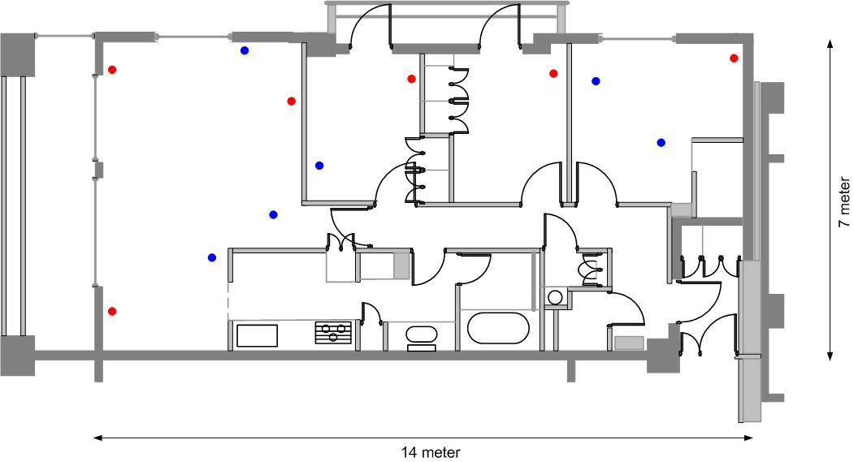
3 | Residen-tial | Digital home  (network maintenance with power saving) | Same deployment assumption is made as above.  Some of the mesh point is not forwarding a packet, and are in the doze mode for power saving, while maintaining network configuration.  The motivation for bringing this usage model is:  Many of the Mesh Points are installed in CE devices such as TV, VCR, STB, Audio Set, etc. Mesh Points with those devices serve WLAN Mesh services regardless of their own application activity. Late at night, most of those applications are in stand-by mode, and the power consumption caused by Mesh Point functionality will be dominant.  To measure possible power saving functionality, as well as network stability, and network maintenance signaling complexity, using this model. Network stability must be somewhat restricted by power saving, but it shall be maintained.
4 | Residen-tial | Digital home  (co-channel utilization with neighbours) | Digital home network may be configured by neighbors also, if TGs successfully creates a large market ☺. Although frequency reuse must be performed as for the closest neighborhoods by means of DFS, etc, some of the neighboring signal could be reachable to the another WLAN Mesh network(another security domain) due to lack of frequency channel.  Appropriate radio resource sharing among the neighbors should be treated as one of the functionality of WLAN Mesh services.  The motivation for bringing this usage model is:  To measure network stability in case of co-channel utilization by different households (network owner) from radio resource management point of view. | Co-channel Residential  Red points denote Mesh Points. 2 Mesh Points located in the hall is aggressor.  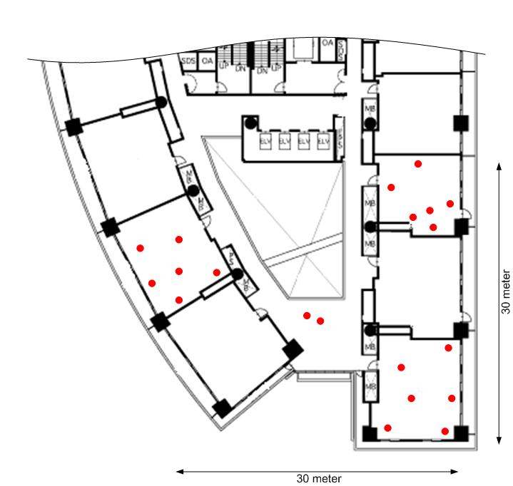
5 | Residen-tial | Digital home  (mis-user) | Similar deployment assumption is made as above.  Digital home network could be affected by malicious aggressor, since the radio wave could be reachable to the network from outside of the home. WLAN Mesh service shall be robust against mis-users.  The motivation for bringing this usage model is:  To measure robustness against aggressor and stability of the network.
6 | Office | Small/ Medium Office | In the small/medium office usage model, the primary purposes for the mesh network are to create low-cost, easily deployable networks with reliable coverage throughout an office building. Mesh APs will mostly be dedicated infrastructure devices, but some PCs may also participate as Mesh APs in the network. STAs may be a combination of PCs, laptops, PDAs, printers, telephones and other devices commonly found in an office environment. Since many small/medium offices do not have large IT departments to manage the networking infrastructure, the mesh network should be self-configuring to allow for easy deployment and management.
7 | Office | Large Enterprise  #1 | In the large enterprise usage model, the primary purposes for the mesh network are to create a low-cost, easily deployable wireless network that provides reliable coverage and performance and is manageable by an IT department. Mesh APs will mostly be dedicated infrastructure devices. STAs may be a combination of PCs, laptops, PDAs, printers, mobile and desktop phones and other devices commonly found in an office environment. Since most large enterprises have an IT department to manage the network infrastructure, the mesh network should be centrally manageable.
8 | Office | Large Enterprise  #2 | Wireless mesh networks can cover broad open areas both indoor and outdoor. Wireless mesh networks are particularly useful in areas where ethernet cabling does not exist or is cost prohibitive to install. With wireless mesh networks, enterprises can reduce capital costs associated with cable installation and reduce time required for deployment. Many enterprises will benefit from an increase in employee productivity through expanded connectivity to key data network resources. Examples are big business / campus, manufacturing plants, government buildings and health care / hospitals.
9 | Campus/ Comm-unity/ Public Access Network | University Campus | Wireless mesh networks can provide cost effective campus wide coverage for faculty and students. Schools may be able to attract students and faculty members with innovative wireless data services. The university avoids cabling and trenching which are costly and disruptive. Students and faculty can enjoy the convenience of data connectivity over the entire campus.
10 | Campus/ Comm-unity/ Public Access Network | Community Area Network  (residential Internet Access) | Community–based wireless internet access built on wireless mesh networks may be used as an alternative to dial-up, DSL, or cable modem service. Wireless mesh networks offer rapid, scaleable, and flexible cost-effective deployment with lower recurring backhaul operational costs. Local programming / advertising can be targeted to interest groups within the neighborhood. Internet service can be provided inside and outside the home, and extended to coffee shops, corner stores, recreational areas and local schools. Community area mesh networks can be used to offer data services to municipalities or public safety initiatives.
11 | Campus/ Comm-unity/ Public Access Network | Residential Access Community Network  #2 | tbd | tbd
12 | Campus/ Comm-unity/ Public Access Network | Inter-building backbone | tbd | 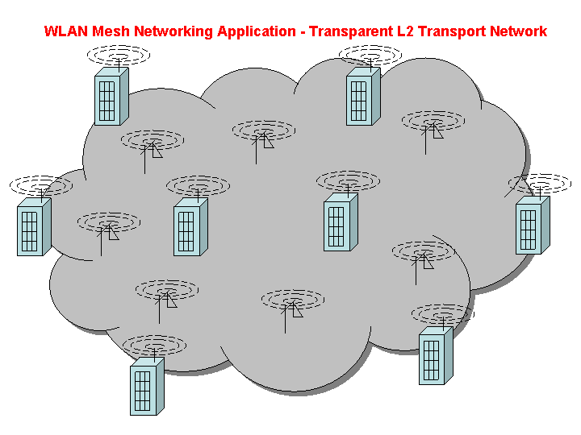  Transparent L2 Transport Service Network
13 | Campus/ Comm-unity/ Public Access Network | Parade or Temporary Event | tbd | tbd
14 | Campus/ Comm-unity/ Public Access Network | Public Access: Urban streets | Groups of people will use VoIP and data-centric services in the HotSpot scenario. At pedestrian speed there will be low mobility and no topology changes of the mesh backbone. If end user devices were capable of mesh technology they could be used as relaying nodes, however, because of battery and privacy constraints, it is assumed that they will not be part of the mesh. The main purpose for the Mesh network in this scenario is ease of deployment and reduction of installation cost.  There are high bandwidth demands and requirements on medium to small delay. | 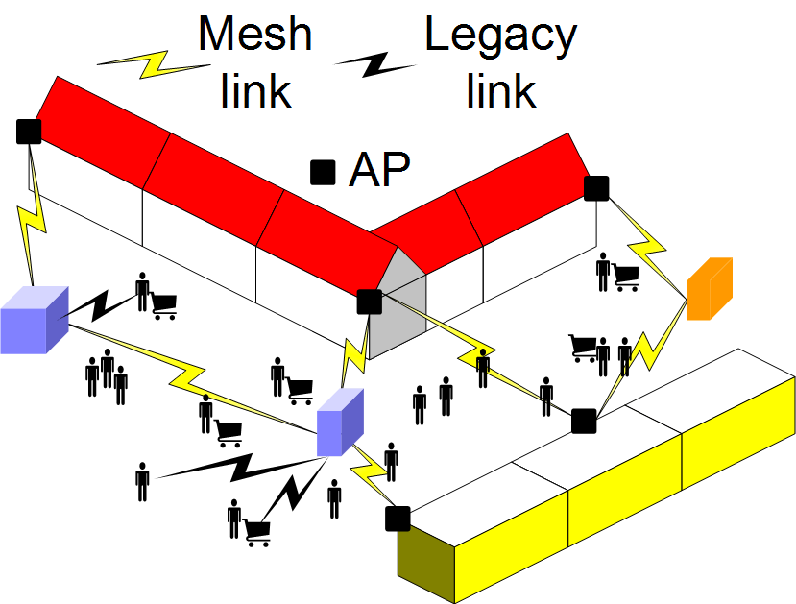
15 | Public Safety | First  Responder | Firefighter company with several trucks responds to fire scene and sets up network. Network tracks firemen with bio-sensors, firemen communicate, upload images, download hazmat information, track air status, equipment location.
16 | Public Safety | Small  Incident Scene | Small incident scene relates to fire/police/emergency personnel responding to an incident scene. Everything is mobile but probably back haul links are from fire trucks or other vehicles that are less mobile, more secure, and have better power. Communications are mostly outdoors but may include communicating with first responders inside (potentially deep inside with contact only by relaying) buildings. Certainly the number of forwarding nodes around may naturally exceed 32 which may require some ability for automatic partitioning into clusters each of which uses 802.11s. | Tbd
17 | Public Safety | Large Incident Scene | Large incident scene relates to fire/police/emergency personnel responding to an incident scene. Everything is mobile but probably back haul links are from fire trucks or other vehicles that are less mobile, more secure, and have better power. Communications are mostly outdoors but may include communicating with first responders inside (potentially deep inside with contact only by relaying) buildings. Certainly the number of forwarding nodes around may naturally exceed 32 which may require some ability for automatic partitioning into clusters each of which uses 802.11s. | Tbd
18 | Public Safety | Public Service Grid | Public Service Grid is the case where large areas are blanketed with pole top radios most of which are co-located with remote surveillance cameras or the like and not all of which are wired to a LAN. Variations in radio propagation, equipment/power failures, etc., make static configuration of the link topology of these radios undesirable. Furthermore, mobile units such as patrolmen and police/emergency vehicles should be able to access services via the nearest pole top radio. | Tbd
19 | Public Safety | Public Safety/ First Responder Community Network |  | tbd
20 | Car2Car | Danger Warning | Car to car (Car2Car) communication enables active safety measures. Danger warnings can be transported on an ad hoc network of cars using 802.11 mesh technology, i.e. informing succeeding cars of accidents or other blockings of the road ahead.  The scenario is characterized by highly mobile stations. The Physical Layer required to support such high speeds will be standardized by 802.11p. However, the mesh networking aspects have to be covered by 802.11s. The Mesh network is subject to frequent topology changes and constant neighbor discovery. All routes and connections have to be set up in a very short time. On the other hand only a small amount of data has to be delivered, however, the delay has to be as small as possible. | 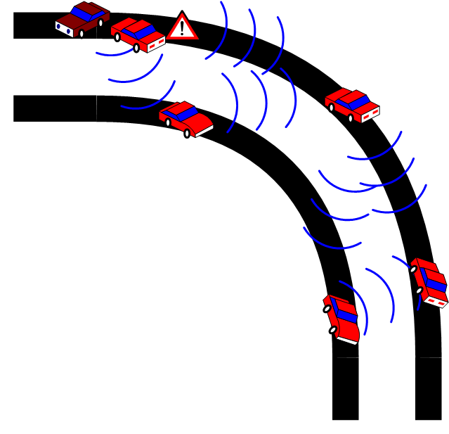
21 |  | Data/Telematics applications | Car-2-car communication enables data applications in cars in urban or rural scenarios where no full WLAN coverage is available. Typical applications are telematics applications for traffic or parking management. In traffic jam scenarios gaming, chatting or other applications are also possible.  The scenario is characterized by medium to fast mobility of the participating stations. The network might be a hybrid of infrastructure-based and ad hoc components. When having a connection to the network each station will download at the highest possible data rate to fill up the internal cache again. The scenario is therefore characterized by high bandwidth demands but less strict delay demands. | 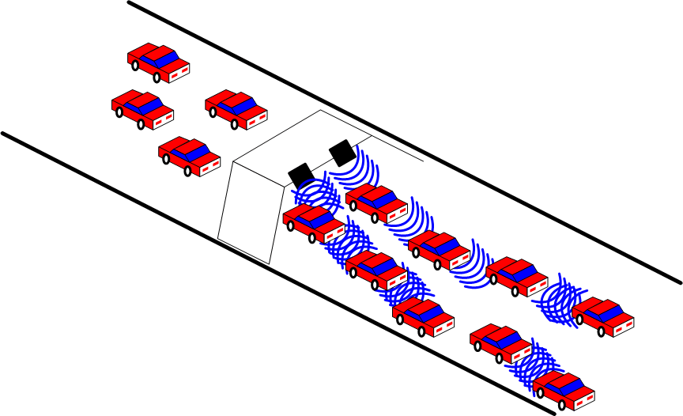

Table 4 - Usage Model Characteristics Table

Usage  Model  # | Usage Model Category | Usage Model  Name | Deployment Characteristics |  |  |  |  |  |  |  |  | Traffic Characteristics |  |  | Unique Security Requirements/ Characteristics | Unique Mesh AP/ Mesh Point Device Characteristics (e.g. power, antenna, etc) | Management and Configuration of WLAN Mesh (Self-configuring or Managed?) | Motivations for WLAN Mesh Deployment | Comments
Usage  Model  # | Usage Model Category | Usage Model  Name | Total  # Mesh APs/  Points | Mesh Physical Topology (Physical Area Size/Shape, Include Sample Topology Map) | Mesh  Deployment Environment | Mesh AP/ Point Mobility | Mesh AP / Point Join / Exit Frequency | # Mesh APs/  Points with Portals to Other LANs | #  STAs | STA distri-bution | STA mobility | Use Cases (Including Applications) | Mesh APs/ Points  may be  Application  End-points? | Both application End-points commonly within the WLAN Mesh?
1 | Residen-tial | Digital  Home  #1 | 8 | 10m x 15m | Indoor | Low | Low | 1 | 20 | (Out of scope) |  | 1, 2, 3, 4, 7, 8, 10, 11, 12, 14, 15, 21, 29, 32, 33 | Yes  (SoftAP PCs and CE Devices) | Yes | Central or Distributed Key management | Omni-antenna | Self-  configuring | Low cost, convenient deployment
2 | Residen-tial | Digital home  #2  (full usage of BW) | Relatively small  (6) | 100m^2  Rectangle (1:2)  [ref to sample topology figure R1] | Indoor | Low | Low | Small  (1) | Small  (6) |  |  |  | Yes.  VCR, TV, desktop PC | Yes. | Distributed key management | Omni-antenna  Some of the mesh point and STA has restricted transmission power. | Self-configuring | Seamless connectivity within home, give always connected experience to users. | Measurement parameter for this scenario is :  Overall E-to-E throughput/jitter at the isolated Mesh and BSS deployment.
3 | Residen-tial | Digital home  (network maintenance with power saving) | Relatively small  (6) | 100m^2  Rectangle (1:2)  [ref to sample topology figure R1] | Indoor | Low | Low | Small  (1) | Small  (6) |  |  |  | Yes.  VCR, TV, desktop PC | Yes. | Distributed key management | Omni-antenna  Most of the mesh points are conscious about power conservation.  Some of the mesh point is not forwarding a packet, and are in the doze mode for power saving whle maintaining network configuration. | Self-configuring | Power saving functionality validation for mesh points within mesh network. | Measurement parameter for this scenario is ;  Power saving validation.  Network maintenance signalling complexity.  Quick recovery from doze mode (mesh point).
4 | Residen-tial | Digital home  (co-channel utilization with neighbours) | Medium  (20) | Approx. 900m^2  (30m x 30m)  [ref to sample topology figure R2] | Indoor | Low | Low | Small  (1) | Small  (3) |  |  |  | Yes.  VCR, TV, desktop PC | Yes. | Distributed key management. Different security domain exists in co-channel. | Omni-antenna | Self-configuring | Robustness against co-channel utilization by the different households from radio resource management point of view. | Measurement parameter for this scenario is ;  Fairness among different mesh network owners, and stability of the network.
5 | Residen-tial | Digital home  (mis-user) | Medium  (20) | Approx. 900m^2  (30m x 30m)  [ref to sample topology figure R2] | Indoor | Low | Low | Small  (1) | Small  (3) |  |  |  | Yes.  VCR, TV, desktop PC | Yes. | Malicious aggressor is trying to peep or destroy mesh network. | Omni-antenna | Self-configuring | Robustness against aggressor provides safety operation of wireless network. | Measurement parameter for this scenario is ;  Robustness against aggressor, and stability of the network.
6 | Office | Small/ Medium Office | 16 | 20m x 40m | Indoor | Low | Low | 2 | 80 |  |  | 1, 9, 10, 18, 29, 30, 31, 33, 36 | Yes  (SoftAP PCs) | Yes | Central or Distributed Key management | Omni-antenna | Self- configuring | Low cost, convenient deployment, reliable coverage
7 | Office | Large Enterprise  #1 | 32 | 6000m^2 | Indoor | Low | Low | 7 | 300 |  |  | 10, 31, 33, 1, 29, 9, 36, 18, 30 | No (Dedicated Mesh APs) | Yes  (Voice, Printing, Projector, etc.) | Central Key Management | Omni-antenna | Managed Configuration | Low cost, convenient deployment, reliable coverage
8 | Office | Large Enterprise  #2 | Large  (50-100) | 8000 m^2  (per AP) | Indoor | Fix | N/A | Medium  (5-10) | Large  (500-2000) |  |  | 1, 9, 10, 11,13,16,18, 29,30, 31, 36,37 | No | No | Central Key management | Directional-antenna | Managed configuration | Productivity, accessibility and lower cost infrastructure
9 | Campus/ Comm-unity/ Public Access Network | University Campus | Large (30-50) | 50 k m^2 – 100 km^2  (per AP) | Outdoor | Fix | N/A | Medium (4-5) | Large (300-1000) |  |  | 2,9,10,11,13, 18,20,21,31 | No | No | Central Key management | Directional antenna | Managed configuration | Accessibility, lower cost infrastructure, border coverage
10 | Campus/ Comm-unity/ Public Access Network | Community Area Network  (residential Internet Access) | Large (100) | 100 k m^2  (per AP) | Outdoor | Fix | N/A | Medium (10) | Large (2000 – 3000) |  |  | 1,2,11,14,21 | No | No | Central Key  management | Directional antenna | Managed configuration | Wireless Internet, lower cost infrastructure, scalability
11 | Campus/ Comm-unity/ Public Access Network | Residential Access Community Network  #2 | Large  (32) | 5 km^2 | Outdoor | Low | Low | Medium  (4-5) | Large  (1000) |  |  | ??? | No | No | Central Key Management | Omni/directional antennas, multiple radios/antennas | Managed configuration | Low cost, reliable coverage
12 | Campus/ Comm-unity/ Public Access Network | Inter-building backbone | Large | 5km^2  [ref to topology figure 1] | Outdoor | Fixed | Low  (restricted access only) | Medium  (8-10)  * Not sure what this field is for? Is it meant for the ratio of # of mesh points to a portal? | N/A |  |  | 6-9, 14, 15, 19, 23, 24, 25 | Yes  (Access switches could be Mesh Portals) | Yes | Distributed key management | Omni, Sector, Smart-antenna | Managed configuration | Reduced deployment time and cost, reliable coverage
13 | Campus/ Comm-unity/ Public Access Network | Parade or Temporary Event | Medium  (16) | 2 km^2 | Outdoor | Medium | Medium | Small  (1-2) | Small  (25) |  |  | ??? | Yes | Yes | Distributed Key Management | Omni antennas | Self-configuring | Low cost, rapid deployment, self-configuring
14 | Campus/ Comm-unity/ Public Access Network | Public Access: Urban access | Middle to large (32) | 50m*10m up to 1000m * 100m | Indoor and outdoor | None | Moderate | Medium – high (32) | Tens to hundred |  |  | 21 | No | No | Central key management | Omni directional | Self-configuring | Point of sales, advertisement, amusement customer attraction | Shopping center (Mall), outlet store etc.
15 | Public Safety | First  Responder | Large  (32) | 250 m^2  Circle  [ref to sample topology figure] | Indoor/Outdoor | Medium | Medium | Medium  (6-8) | Medium  (50) |  |  | Apps: 1,7,8,9,14,15,19; Use: 7,8,9,10,13,15,28,30,31,32,33,37 | Yes | Yes | Central or Distributed Key management | Omni or directional | Self-  configuring | No Infrasturcture,Low cost,fast depoloy | Wireless portal to Internet (cellular)
16 | Public Safety | Small  Incident Scene | Medium (20) | 1000 m^2 | Mostly Outdoor | High | High | Small  (2-3) | Small  (30) |  |  | 11, 37, 41, 42 | Yes | Yes | Central Key management, users hierarchically organized |  | Self-  configuring | Mesh improves range, reachability, battery life
17 | Public Safety | Large Incident Scene | Very Large (100) | 1 km^2 | Mostly Outdoor | High | High | Large  (10-20) | Large (250) |  |  | 11, 37, 41, 42 | Yes | Yes | Like DE-2 but may have several organizations with disjoint management |  | Self-  configuring | Mesh improves range, reachability, battery life
18 | Public Safety | Public Service Grid | Very Large (100s) | 100 km^2 | Outdoor | Low | Low | Very Large (50-100) | Large (250) |  |  | 7, 11, 13, 37, 41, 42 | Yes | No, most paths back to persons/services on fixed LAN |  |  | Self-  configuring | Low cost, convenient deployment, reliable coverage
19 | Public Safety | Public Safety/ First Responder Community Network | Large  (32) | 5 km^2 | Outdoor | Low | Low | Small  (1-2) | Low  (25) |  |  | ??? | No | No | Central Key Management | Omni/ directional antennas, multiple radios/ antennas | Managed configuration | Low cost, reliable coverage
20 | Car2Car | Danger Warning | Depending on number of cars | From urban (10m*100m) to highway (1000m*30m) dimesnion | Outdoor | Extremely high | High | 0 | High (up to some hundreds in traffic jam situation) |  |  | 20 | Yes | Yes | Distributed key management | Omni directional | Self-configuring | Driver safety | Low data to transmit, however very challenging due to high speed mobility
21 | Car2Car | Data/Telematics applications | Depending of number of cars |  | Outdoor | Moderate to low | Low | 1-2 covering many cars | High (up to some hundreds in traffic jam situation) |  |  | 20 | Yes | Yes | Central key management possible | Omni directional | Self-configuring | Data access in car

Detailed Simulation Scenarios
This section is a placeholder for more detailed descriptions of usage models, including enough details to specify simulation scenarios. These simulation scenarios will include a specification of a representative topology, one or more channel model, mapping of application endpoints to devices in the topology, and other simulation parameters.

Table 5 - Environment to Channel Model Mapping
Model | Environment
A | Flat fading (no multipath)
B | Residential
C | Residential / Small Office
D | Typical Office
E | Large Office
F | Large Space (indoors / outdoors)

Channel model specifications TBD.

Appendix

Applications
Table 1 lists the applications that are referred to from the usage models, together with relevant traffic parameters. The primary purpose of this table is to allow concrete application expectations/ requirements to be included in usage model descriptions. Packet loss rate and maximum delay values listed in this table represent the end-to-end loss and delay budgets required for the various applications. When defining evaluation criteria and detailed simulation scenarios for particular usage models, this table will also be useful for evaluating whether proposed routing protocols and/or MAC enhancements for 802.11s will be able to support application requirements under different configurations (e.g. topology, PHY/MAC choice, etc).

The parameters are defined as follows:
- MSDU size: Packet size at the top of the MAC
- Maximum E2E PLR: Maximum end-to-end packet loss rate at the top of the MAC. This is defined by the loss rate that can be tolerated by the application.
- Maximum E2E Delay: Maximum end-to-end transport delay at the top of the MAC – i.e. between matching MA-UNITDATA.request and .indication.
- Protocol: Indicates the network-layer protocol running between the data source and the MAC. It takes one of two values: TCP or UDP. These are intended to represent a generic acknowledged and a generic unacknowledged network-layer protocol.

Note on E2E characteristics: 802 .11s scenarios will often require data to be transmitted over multiple radio hops. Thus, when considering application performance characteristics we must consider the overall performance across multiple hops (not just across one link). This was the rationale for listing end-to-end characteristics.

Note on the meaning of "Offered load" and "Protocol". Applications identified as being carried by UDP are assumed to generate MSDUs at a fixed rate, as identified in the "Offered load" column. Inability to carry the traffic generated by a UDP application, due to insufficient throughput capability, results in lost MSDUs, which is reported in simulation results as a packet loss rate, or an outage, associated with the application. The comparison criteria may include a measure of whether this packet loss rate exceeds the maximum specified for the application in this table.

Traffic carried by TCP is assumed to be served on a best-effort basis, and applications using TCP are assumed to generate MSDUs at rates up to the
value given in the "Offered load" column. Being an acknowledged protocol with a constrained window size, TCP responds to congestion in the BSS by reducing application throughput without losing MSDUs. This effect may be reflected in simulation results by reporting achieved throughput for applications using TCP. Note: Acknowledgement traffic is generated by TCP sinks, this is not explicitly specified in the simulation scenarios, but it is included in the count of non-QoS flows and measurement of goodput.

The delay and PLR requirements for each application are specified in Table 1. Simulations may map applications and flows to specific QoS classes as necessary to satisfy these requirements. Proposers shall clearly state how applications and flows are mapped to specific QoS classes in their simulations.

Table 6 - Application Definitions
Number | Application | Offered Load (Mbps) | Protocol | MSDU Size (B) | Maximum E2E PLR | Maximum E2E Delay (ms) | Source  [ref]
1 | DV Audio/video | 28.8 | UDP | 1024, Is this true? All other video/audio (SDTV, HDTV) transfers has this parameter set to 1500. | 10^-7  (corresponds to a rate of 0.5 loss/hour) | 200 | SD Specifications of Consumer-Use Digital VCRs  Max PLR: 15-03-276r0
2 | VoD control channel | 0.06 | UDP | 64 | 10^-2 | 100 | 11n Guess
3 | SDTV | 4-5 | UDP | 1500 | 5*10^-7 | 200 | 1
4 | HDTV (Video/Audio) | 19.2-24 | UDP | 1500 | 10^-7 | 200 | 1
5 | DVD | 9.8 peak | UDP | 1500 | 10^-7 | 200 | 1
6 | Video Conf | 0.128 - 2 | UDP | 512 | 10^-2 | 100 | 1
7 | Internet Streaming video/audio | 0.1 – 4 | UDP | 512 | 10^-2 | 200 | 1
8 | Internet Streaming audio | 0.064~0.256 | UDP | 418 | 10^-4 | 200 | 11n Group guess
9 | VoIP | 0.02 – 0.15 | UDP | 100 | 5% | 300 | ITU-T G.114 300ms round-trip delay
10 | MP3 Audio  Other formats are taking over (AAC/MPEG-4, OggVorbis, etc) | 0.064 – 0.32 | UDP | 418 | 10^-4 | 200 | 1
11 | Content download (photo camera) | 11 (typical, but highly variable) | TCP | 1500 | n/a |  | Corresponds to USB and flash speed
12 | Internet File transfer (email, web, chat) | 1 (typical, but highly variable) | TCP | 300 | n/a
13 | Local File transfer, printing | 30 (typical, but highly variable) | TCP | 1500 | n/a
14 | Interactive Gaming  [Controller to Console x 1] | 0.5 | UDP | 50 | 10^-4 | 16 | 2
15 | Interactive Gaming  [Console to Display] | 100+ | UDP | 1500 | 10^-2 | 10 | 2  video image: 320x240x15 @ 60Hz
16 | Interactive Gaming  [Console to Internet Access]  *NOTE : Depends on Game Type | 1 | UDP | 512 | 10^-4 | 50ms | 11n Group consensus
17 | Netmeeting application/desktop sharing | 0.5 | TCP | 512 | n/a |  | 11n Group guess
18 | Video phone | 0.5 | UDP | 512 | 10^-2 | 400 | IMT-2000
19 | Remote user interface (X11, Terminal Server Client)  (remote display/keyboard/mouse) | 0.5-1.5 (peak) | UDP | 700 | n/a | 100 | 11-03-0696r0
20 | BioSensor Data | .1 - .5 | UDP | ? | ? |  | JRA guess based on .5s update
21 | Provide transparent L2 transport services among buildings of a campus | 1.0+ | L2, L3 protocols | Up to 1500 | n/a | n/a

Use Cases
contains a definition of the use cases used in this document. Use cases provide context about how various applications are used in usage models. The same use case can potentially be used in multiple usage models, so use cases are referenced from this table rather than being listed in detail within usage model descriptions.

Table 7 - Use Case Definitions
Number | Use case | Application | Typical Environment (not exclusive) | Both Application Endpoints within the WLAN Mesh?
1 | One personal phone everywhere – home, office. Each person has a phone that works everywhere, home, office – same number. An extension of the cell phone into the office building. This includes cordless phone over VoIP. | VOIP integrated with other wireless WAN technologies | Residential, Enterprise – large and small, conference room | Usually no
2 | Multiplayer Internet gaming anywhere within the home / Internet Café. | Interactive gaming (console to internet), internet gaming (controller to console) | Residential/small enterprise (internet cafes) | Usually no
3 | Multiple TVs running throughout the home getting their content from a single remotely located AV-server/AP/set top box. Local control of the content (changing channels, etc). | HDTV, SDTV, VoD control channel | Residential | Yes
4 | Link the home digital camera/video to the TV/display for display of pictures and movies taken. | DV Audio/Video | Residential | Yes
5 | Watch a movie of your choice, when you want it, it your hotel room. | Internet streaming audio/video, SDTV, HDTV | Hotspot | Usually no
6 | Watch a clear replay of an event from your seat in a sporting arena. | Internet Streaming Video | Outdoor | Usually no
7 | Remotely located security cameras transmitting video signal to a monitoring location. | SDTV | Outside/Inside Residential, Small office building (not covered) | Usually no
8 | Music real time on multiple receivers throughout the home from a remotely located AV-server/AP/set top box receiver. | PCM Audio, MP3 Audio | Residential | Yes
9 | Net meeting in a conference/class room to share someone’s display. 30 participants/students | Netmeeting application/desktop sharing | Conference room/class room | Sometimes
10 | Reconfigurable / temporary office space, Ethernet cable replacement (similar throughput to wired cable). Back up files, email, web surfing, printing, etc. | Local File Transfer, printing | Enterprise – sea of cubes, home, hotel | Sometimes
11 | Download video, music and other data files to a device in an automobile in the home garage or driveway. Broadband file transfer – at HT rates. | Internet File Transfer | Residential / Outdoor | Sometimes
12 | Backup/transfer files between PCs located throughout the home, printing. Access point router. | Local File Transfer | Residential | Yes
13 | Synchronize your local device with the server – email, calendar, etc. Hot spot/airport/airplane | Internet File Transfer | Large open area – hot spot, airport, train station, bus terminal. Airplane, Train | Usually no
14 | Download digital pictures and home movies to a PC/AV-server | Content download | Residential | Yes
15 | Exchange files between PCs or between CE devices | Local File Transfer | Residential | Yes
16 | Update inventory from the warehouse and the retail floor. | Local File Transfer | Industrial | Usually no
18 | Access of networked software from the classroom. 30 participants, simultaneously signing on. | Local File Transfer | Conference room/class room | Sometimes
19 | Update/view medical records from patient rooms. | Local File Transfer | Industrial. | Sometimes
20 | Obtain real time interactive player and game stats from your seat at a sporting event. | Internet File Transfer | Outdoor | Usually no
20.5 | View broadcast SDTV video/audio at a sporting event | SDTV | Outdoor / Arena | No
20.6 | View Video on demand at a sporting event / concert-hall /hotspot | SDTV | Outdoor / Arena | No
21 | Interactive multi-person gaming – ad hoc. | Interactive gaming | Home, train station | Yes
28 | Real-time streaming of ultrasound video and real-time viewing of x-ray/MRI/CT images as well as medical diagnostics signal streams / patient monitoring data | SDTV, local file transfer | Hospital (Industrial) similar to Large Enterprise (?) | Sometimes
29 | Online distance learning/broadcasting locally | Internet File Transfer, Internet Streaming Audio/Video | Residential, small/large enterprises | No
30 | Video conferencing with headset | Internet Streaming video/audio + headset interference | Small Enterprise | Usually no
31 | Enterprise high stress. Surfing the web, e-mail, printing, file transfers within the intranet. | Internet File Transfer.  Printing.  Local File Transfer | Small/Large Enterprise | Sometimes
32 | Portable /Internet AV Devices. MP3 or other player playing music directly from an internet through a residential gateway. | Internet Streaming Audio | Residential | No
33 | AV Communication  Video Phone: Peer to peer AV communication.  Video Conferencing: AV conference between multiple devices | Internet Streaming Video/Audio (multicast/broadcast) | Residential, Small/large Enterprise | Usually no
36 | Enterprise conference room – 20 to 30 users | Local file transfer, internet file transfer, printing | Enterprise | Sometimes
37 | Lightweight terminal wirelessly connected to a remote computer | Remote user interface | Residential, Industrial,  Enterprise | Sometimes
38 | Enterprise VPN | Secure Tunneling through the mesh | Residential, Industrial,  Enterprise | Usually no
39 | Firefighters | Internet File Transfer  Audio/Video (multi-,broad-cast)  Bio-sense data  Gateway (Portal) to cellular or sat nets | Indoor/Outdoor | Yes
40 | A company, hospital, or university campus composed of a few nearby buildings interconnected by a set of mesh points at the top of each building and light posts in-between buildings to form an inter-building backbone | L2 transport service | Large enterprise | Yes
41 | Command and Control Voice | VOIP? with group broadcast and pre-emption by privileged stations | Incident scenes | Usually
42 | Emergency signal | Fire/burglar alarms, “man down” button on station, etc. (High priority, very low bandwidth, may wish to by-pass some security) | All | Sometimes
43 | Home environment, CE  Several Consumer Electronics (CE) devices spread across an apartment;  worst case: several apartments in a skyscraper/tall building, neighbors to the left, right, below, above and behind; | Streaming of video and audio files;  Video games, streaming between TV and games console; download of picture and data from portable to home devices, VoIP all over the apartment, Internet access; | Indoor, house with several floors and brick walls or apartment in apartment building | Yes
44 | Public Access  Public mesh network in a city for urban annotation and data-centric applications; high density of meshed APs (distance ~50 meters) in certain areas; several APs are connected through one gateway | Information services (traffic, urban), VoIP, some streaming applications;  Eventually SoHo applications (broadband access) | City street, Airport and train station, supermarket area, mall and shopping centre area | No
45 | Car2Car  A multitude of highly mobile cars on a highway or in a city; varying density of the nodes from a few meters distance (in a traffic jam) to one kilometer; mesh networking among the cars; 250km/h | Wireless Local Danger Warning for among cars;  Navigation support;  Traffic jam information;  Cacheable data transportation | Roadside, Highway, City | No for entertainment and information applications;  Yes for danger and emergency application

Note, this corresponds to a loss of a 1024B MSDU per hour. The TS PDU PLR is higher than this. It is not known what is the effect to the decoder of giving it burst packet losses.
Note, a PLR of 10^-7 will not be measurable in our simulation technologies.
Note, this corresponds to a loss of a 1024B MSDU per hour. The TS PDU PLR is higher than this. It is not known what is the effect to the decoder of giving it burst packet losses.
Note, a PLR of 10^-7 will not be measurable in our simulation technologies.

