IEEE P802.11
Wireless LANs
Usage Models

Date: June 17, 2004

Authors/Contributors:
Name | Company | Address | Phone | Fax | Email
W. Steven Conner | Intel Corporation
Jonathan Agre | Fujitsu
Hidenori Aoki | NTT DoCoMo
Kevin Dick | Nortel Networks
Donald Eastlake | Motorola
Tyan-Shu Juo | Janysus Networks
Ted Kuo | Janysus Networks
Yoichi Matsumoto | NTT DoCoMo
Kazuyuki Sakoda | Sony
Tricci So | Nortel Networks
Raymond Yung | Conexant

Abstract

This document defines usage models for 802.11 TGs, intended to be used to define the functional requirements for ESS Mesh and to specify well-defined simulation scenarios.

Revision History
Revision | Comments | Date | Author
R0 | Initial draft based on TGn Usage Models document 11-03-0802r16 | May 21, 2004 | SC
R1 | Edits and additions from ad-hoc group comments | May 30, 2004 | SC + contributions from adhoc group
R2 | Added additional notes on purpose of applications and use cases and more detailed instructions for filling out usage model template. | June 4, 2004 | SC
R3 | Edits based on feedback and new integrated contributions  - reorganized usage model section with two tables, one for high level descriptions and topologies and the other for collecting more detailed characteristics  - integrated all usage model examples, modifications, and comments received to-date  - started abbreviations and acronyms table for completeness  - added clarifying description text to applications and usage model sections  - renumbered applications, removing skipped numbers  - added additional example applications and use cases | June 17, 2004 | SC + contributions from adhoc group

Introduction
To support the definition of the 802.11 ESS Mesh WLAN standard within the IEEE (to be published eventually as the 802.11s amendment), this document attempts to define usage models based on various market-based use-cases. The usage models are intended to support the definitions of network simulations that will allow 802.11 TGs to evaluate the performance of various proposals in terms of, for example, network throughput, delay, packet loss and other metrics. It is anticipated that the outputs of this document will aid in the subsequent development of the evaluation and selection criteria used by TGs.

Note - These usage models that the usage model committee develops here are subject to the following constraints :
C1: They are relevant to the expected uses of the technology
C2: They pose a specific problem that can be addressed with 802.11 ESS mesh technology
C3: They are capable of being turned into an unambiguous simulation scenario

Process going forward
The following is a suggested process for developing usage model descriptions for TGs that will be useful for driving specific functional requirements, simulation scenarios, and evaluation criteria for 802.11s proposals.

- A usage model description template will be created to allow volunteers to describe different usage models in a consistent, comparable fashion.
- Volunteers will fill in the template with descriptions of different usage models of interest for TGs, including sample deployment topologies for each usage model.
- Usage model descriptions will be revised and prioritized based on group feedback.
- Detailed simulation scenarios will be defined for high priority usage models. These simulation scenarios will include a specification of a representative topology, one or more channel model, mapping of application endpoints to devices in the topology, and other simulation parameters.

Definitions
This section defines some of the terms used in this document.

Application – a source or sink of wireless data that relates to a particular type of user activity.
Examples: Streaming video. VOIP.

Environment – The type of place a WLAN system is deployed in. Initial examples: home, large office.

Use case – A use case is a description of how an end user uses a system that exercises that system’s deployment of WLAN. A use case includes an application with details regarding the user activity and both sides of the end-to-end link.

Usage Model – A specification of one or more applications and environments from which a simulation scenario can be created once the traffic patterns of the applications are known. Usage models are created to "cover" use cases.

Simulation Scenario – A simulation scenario is a description of a usage model that supports simulation. A simulation scenario includes details needed for simulation. Types of details to be included are descriptions that link the usage model to the simulation scenario: environment linked to a channel model, position of the Mesh APs and Mesh Points, uplink and downlink traffic, etc. A simulation scenario is created from a Usage Model by characterising the traffic profile of the applications and possibly merging multiple applications together to reduce simulation time.

Abbreviations and Acronyms
DV Digital Video
HDTV High Definition TV
MSDU MAC Service Data Unit
PLR Packet Loss Rate
SDTV Standard Definition TV
TCP Transmission Control Protocol
UDP User Datagram Protocol
VoD Video on Demand
VoIP Voice Over Internet Protocol

Mappings between Application, Use case, Usage Model and Simulation Scenario

Understanding and defining the application, use case, usage model and simulation scenario are all necessary to create comparative results from 802.11 TGs proposals.

Each use case involves the use of one or more applications. It represents a single type of use of a system using the technology.

Each application reflects a source or sink of data. They will eventually be characterised in terms of a traffic profile that allows a simulation of the application to be created.

Each usage model contains a representative mixture of applications and channel models designed to adequately cover the important use cases. There is a many to many mapping between use cases and usage models (i.e., the same use case may contribute to multiple usage models and the same usage model may include applications from multiple use cases).

There will be a one-to-one mapping between usage models and simulation scenarios. The usage model is a marketing-oriented description of a "reasonable mixture" covering the important use cases. The simulation scenario fills in any technical details necessary to fully define the simulation inputs not present in the usage model.

Applications
Table 1 lists the applications that are referred to from the usage models, together with relevant traffic parameters. The primary purpose of this table is to allow concrete application expectations/ requirements to be included in usage model descriptions. Packet loss rate and maximum delay values listed in this table represent the end-to-end loss and delay budgets required for the various applications. When defining evaluation criteria and detailed simulation scenarios for particular usage models, this table will also be useful for evaluating whether proposed routing protocols and/or MAC enhancements for 802.11s will be able to support application requirements under different configurations (e.g. topology, PHY/MAC choice, etc).

The parameters are defined as follows:
- MSDU size: Packet size at the top of the MAC
- Maximum E2E PLR: Maximum end-to-end packet loss rate at the top of the MAC. This is defined by the loss rate that can be tolerated by the application.
- Maximum E2E Delay: Maximum end-to-end transport delay at the top of the MAC – i.e. between matching MA-UNITDATA.request and .indication.
- Protocol: Indicates the network-layer protocol running between the data source and the MAC. It takes one of two values: TCP or UDP. These are intended to represent a generic acknowledged and a generic unacknowledged network-layer protocol.

Note on E2E characteristics: 802 .11s scenarios will often require data to be transmitted over multiple radio hops. Thus, when considering application performance characteristics we must consider the overall performance across multiple hops (not just across one link). This was the rationale for listing end-to-end characteristics.

Note on the meaning of "Offered load" and "Protocol". Applications identified as being carried by UDP are assumed to generate MSDUs at a fixed rate, as identified in the "Offered load" column. Inability to carry the traffic generated by a UDP application, due to insufficient throughput capability, results in lost MSDUs, which is reported in simulation results as a packet loss rate, or an outage, associated with the application. The comparison criteria may include a measure of whether this packet loss rate exceeds the maximum specified for the application in this table.

Traffic carried by TCP is assumed to be served on a best-effort basis, and applications using TCP are assumed to generate MSDUs at rates up to the
value given in the "Offered load" column. Being an acknowledged protocol with a constrained window size, TCP responds to congestion in the BSS by reducing application throughput without losing MSDUs. This effect may be reflected in simulation results by reporting achieved throughput for applications using TCP. Note: Acknowledgement traffic is generated by TCP sinks, this is not explicitly specified in the simulation scenarios, but it is included in the count of non-QoS flows and measurement of goodput.

The delay and PLR requirements for each application are specified in Table 1. Simulations may map applications and flows to specific QoS classes as necessary to satisfy these requirements. Proposers shall clearly state how applications and flows are mapped to specific QoS classes in their simulations.

Table 1 - Application Definitions
Number | Application | Offered Load (Mbps) | Protocol | MSDU Size (B) | Maximum E2E PLR | Maximum E2E Delay (ms) | Source  [ref]
1 | DV Audio/video | 28.8 | UDP | 1024, Is this true? All other video/audio (SDTV, HDTV) transfers has this parameter set to 1500. | 10^-7  (corresponds to a rate of 0.5 loss/hour) | 200 | SD Specifications of Consumer-Use Digital VCRs  Max PLR: 15-03-276r0
2 | VoD control channel | 0.06 | UDP | 64 | 10^-2 | 100 | 11n Guess
3 | SDTV | 4-5 | UDP | 1500 | 5*10^-7 | 200 | 1
4 | HDTV (Video/Audio) | 19.2-24 | UDP | 1500 | 10^-7 | 200 | 1
5 | DVD | 9.8 peak | UDP | 1500 | 10^-7 | 200 | 1
6 | Video Conf | 0.128 - 2 | UDP | 512 | 10^-2 | 100 | 1
7 | Internet Streaming video/audio | 0.1 – 4 | UDP | 512 | 10^-2 | 200 | 1
8 | Internet Streaming audio | 0.064~0.256 | UDP | 418 | 10^-4 | 200 | 11n Group guess
9 | VoIP | 0.02 – 0.15 | UDP | 100 | 5% | 300 | ITU-T G.114 300ms round-trip delay
10 | MP3 Audio  Other formats are taking over (AAC/MPEG-4, OggVorbis, etc) | 0.064 – 0.32 | UDP | 418 | 10^-4 | 200 | 1
11 | Content download (photo camera) | 11 (typical, but highly variable) | TCP | 1500 | n/a |  | Corresponds to USB and flash speed
12 | Internet File transfer (email, web, chat) | 1 (typical, but highly variable) | TCP | 300 | n/a
13 | Local File transfer, printing | 30 (typical, but highly variable) | TCP | 1500 | n/a
14 | Interactive Gaming  [Controller to Console x 1] | 0.5 | UDP | 50 | 10^-4 | 16 | 2
15 | Interactive Gaming  [Console to Display] | 100+ | UDP | 1500 | 10^-2 | 10 | 2  video image: 320x240x15 @ 60Hz
16 | Interactive Gaming  [Console to Internet Access]  *NOTE : Depends on Game Type | 1 | UDP | 512 | 10^-4 | 50ms | 11n Group consensus
17 | Netmeeting application/desktop sharing | 0.5 | TCP | 512 | n/a |  | 11n Group guess
18 | Video phone | 0.5 | UDP | 512 | 10^-2 | 400 | IMT-2000
19 | Remote user interface (X11, Terminal Server Client)  (remote display/keyboard/mouse) | 0.5-1.5 (peak) | UDP | 700 | n/a | 100 | 11-03-0696r0
20 | BioSensor Data | .1 - .5 | UDP | ? | ? |  | JRA guess based on .5s update
21 | Provide transparent L2 transport services among buildings of a campus | 1.0+ | L2, L3 protocols | Up to 1500 | n/a | n/a

Use Cases
contains a definition of the use cases used in this document. Use cases provide context about how various applications are used in usage models. The same use case can potentially be used in multiple usage models, so use cases are referenced from this table rather than being listed in detail within usage model descriptions.

Table 2 - Use Case Definitions
Number | Use case | Application | Typical Environment (not exclusive) | Both Application Endpoints within the WLAN Mesh?
1 | One personal phone everywhere – home, office. Each person has a phone that works everywhere, home, office – same number. An extension of the cell phone into the office building. This includes cordless phone over VoIP. | VOIP integrated with other wireless WAN technologies | Residential, Enterprise – large and small, conference room | Usually no
2 | Multiplayer Internet gaming anywhere within the home / Internet Café. | Interactive gaming (console to internet), internet gaming (controller to console) | Residential/small enterprise (internet cafes) | Usually no
3 | Multiple TVs running throughout the home getting their content from a single remotely located AV-server/AP/set top box. Local control of the content (changing channels, etc). | HDTV, SDTV, VoD control channel | Residential | Yes
4 | Link the home digital camera/video to the TV/display for display of pictures and movies taken. | DV Audio/Video | Residential | Yes
5 | Watch a movie of your choice, when you want it, it your hotel room. | Internet streaming audio/video, SDTV, HDTV | Hotspot | Usually no
6 | Watch a clear replay of an event from your seat in a sporting arena. | Internet Streaming Video | Outdoor | Usually no
7 | Remotely located security cameras transmitting video signal to a monitoring location. | SDTV | Outside/Inside Residential, Small office building (not covered) | Usually no
8 | Music real time on multiple receivers throughout the home from a remotely located AV-server/AP/set top box receiver. | PCM Audio, MP3 Audio | Residential | Yes
9 | Net meeting in a conference/class room to share someone’s display. 30 participants/students | Netmeeting application/desktop sharing | Conference room/class room | Sometimes
10 | Reconfigurable / temporary office space, Ethernet cable replacement (similar throughput to wired cable). Back up files, email, web surfing, printing, etc. | Local File Transfer, printing | Enterprise – sea of cubes, home, hotel | Sometimes
11 | Download video, music and other data files to a device in an automobile in the home garage or driveway. Broadband file transfer – at HT rates. | Internet File Transfer | Residential / Outdoor | Sometimes
12 | Backup/transfer files between PCs located throughout the home, printing. Access point router. | Local File Transfer | Residential | Yes
13 | Synchronize your local device with the server – email, calendar, etc. Hot spot/airport/airplane | Internet File Transfer | Large open area – hot spot, airport, train station, bus terminal. Airplane, Train | Usually no
14 | Download digital pictures and home movies to a PC/AV-server | Content download | Residential | Yes
15 | Exchange files between PCs or between CE devices | Local File Transfer | Residential | Yes
16 | Update inventory from the warehouse and the retail floor. | Local File Transfer | Industrial | Usually no
18 | Access of networked software from the classroom. 30 participants, simultaneously signing on. | Local File Transfer | Conference room/class room | Sometimes
19 | Update/view medical records from patient rooms. | Local File Transfer | Industrial. | Sometimes
20 | Obtain real time interactive player and game stats from your seat at a sporting event. | Internet File Transfer | Outdoor | Usually no
20.5 | View broadcast SDTV video/audio at a sporting event | SDTV | Outdoor / Arena | No
20.6 | View Video on demand at a sporting event / concert-hall /hotspot | SDTV | Outdoor / Arena | No
21 | Interactive multi-person gaming – ad hoc. | Interactive gaming | Home, train station | Yes
28 | Real-time streaming of ultrasound video and real-time viewing of x-ray/MRI/CT images as well as medical diagnostics signal streams / patient monitoring data | SDTV, local file transfer | Hospital (Industrial) similar to Large Enterprise (?) | Sometimes
29 | Online distance learning/broadcasting locally | Internet File Transfer, Internet Streaming Audio/Video | Residential, small/large enterprises | No
30 | Video conferencing with headset | Internet Streaming video/audio + headset interference | Small Enterprise | Usually no
31 | Enterprise high stress. Surfing the web, e-mail, printing, file transfers within the intranet. | Internet File Transfer.  Printing.  Local File Transfer | Small/Large Enterprise | Sometimes
32 | Portable /Internet AV Devices. MP3 or other player playing music directly from an internet through a residential gateway. | Internet Streaming Audio | Residential | No
33 | AV Communication  Video Phone: Peer to peer AV communication.  Video Conferencing: AV conference between multiple devices | Internet Streaming Video/Audio (multicast/broadcast) | Residential, Small/large Enterprise | Usually no
36 | Enterprise conference room – 20 to 30 users | Local file transfer, internet file transfer, printing | Enterprise | Sometimes
37 | Lightweight terminal wirelessly connected to a remote computer | Remote user interface | Residential, Industrial,  Enterprise | Sometimes
38 | Enterprise VPN | Secure Tunneling through the mesh | Residential, Industrial,  Enterprise | Usually no
39 | Firefighters | Internet File Transfer  Audio/Video (multi-,broad-cast)  Bio-sense data  Gateway (Portal) to cellular or sat nets | Indoor/Outdoor | Yes
40 | A company, hospital, or university campus composed of a few nearby buildings interconnected by a set of mesh points at the top of each building and light posts in-between buildings to form an inter-building backbone | L2 transport service | Large enterprise | Yes
41 | Command and Control Voice | VOIP? with group broadcast and pre-emption by privileged stations | Incident scenes | Usually
42 | Emergency signal | Fire/burglar alarms, “man down” button on station, etc. (High priority, very low bandwidth, may wish to by-pass some security) | All | Sometimes

Usage Models
Table 3 includes a brief description and example topology for the usage models defined by this document. Table 4 summarizes important characteristics for each usage models defined by this document.

The purpose of these models is to merge representative use cases to create a small number of credible worst-case mixtures of applications. Usage models also include deployment characteristics. The usage models have to be realistic (in terms that they are covered by the use cases listed above), different from each other and cover some subset of the use cases that are identified to be priorities and capable of implementation in proposed 802.11s technology.

The high-level usage model characteristics captured in these tables are intended to capture different expectations, assumptions, and characteristics of mesh network deployments for different scenarios. The tables are intended to be a guideline to allow different volunteers to create comparable usage model descriptions. However, it is not meant to limit the inclusion of relevant characteristics that are not explicitly listed in a column header. If you have additional characteristics for a usage model that are not explicitly listed in an existing column in the table, please feel free to note them under a related column or in the comments column.

Note that the primary focus for usage model topology descriptions and deployment characteristics is on Mesh Points and Mesh APs, based on the scope of 802.11s.

Table 3 - Usage Model Descriptions and Sample Topologies Table
Usage  Model  # | Usage Model Category | Usage Model  Name | Description of Usage Model | Sample Topology  Mesh  APs  /Points with portals to other LANs  Mesh  APs  /Points  Mesh  APs  /Points with portals to other LANs  Mesh  APs  /Points  Mesh  APs  /Points with portals to other LANs  Mesh  APs  /Points  Mesh  APs  /Points with portals to other LANs  Mesh  APs  /Points
1 | Residen-tial | Digital  Home  #1 | In the digital home usage model, the primary purposes for the mesh network are to create low-cost, easily deployable, high performance wireless coverage throughout the home. The mesh network should help to eliminate RF dead-spots. The most demanding usage of bandwidth in the mesh network is expected to come from device-to-device communication, e.g. multi-media content distribution between different devices in the home. Mesh Points and Mesh APs may be a combination of dedicated AP devices, PCs, and high-bandwidth CE devices with line-power supply such as TVs, media center devices, and game consoles. STAs may be a combination of computing devices such as PCs, laptops, and PDAs, CE devices such as digital cameras, MP3 players, DVD players, and home automation devices such as control panels. In the short-term (3-5 years), the home network is expected to consist of a small number of Mesh APs/Mesh Points that are primarily dedicated devices or PCs. In the longer-term (5+ years), a larger number of CE devices are expected to become Mesh APs/Mesh Points, increasing the size of the mesh network over time. A mesh network should be self-configuring to allow easy installation by non-technical consumers.
2 | Residen-tial | Digital home  #2  (full usage of BW) |  | Isolated Residential  Red points denote Mesh Points, and blue points denote STA. Two of the Mesh Points are Mesh APs.  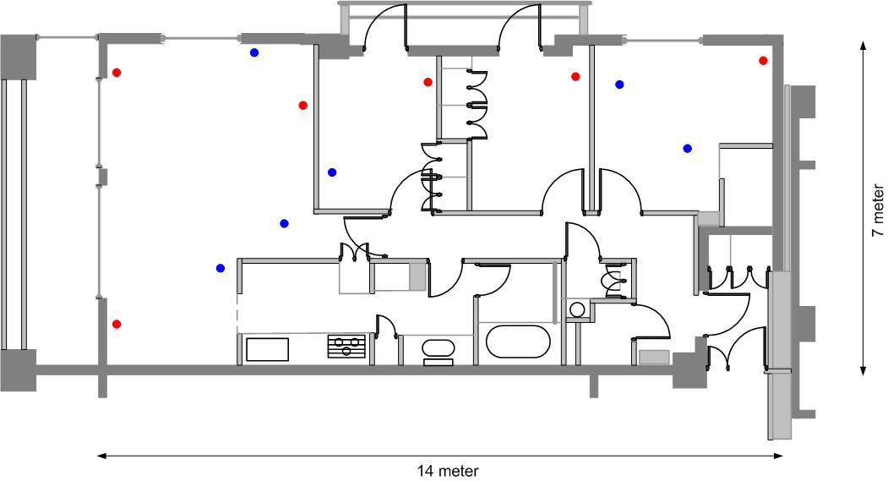
3 | Residen-tial | Digital home  (network maintenance with power saving)
4 | Residen-tial | Digital home  (co-channel utilization with neighbours) |  | Co-channel Residential  Red points denote Mesh Points. 2 Mesh Points located in the hall is aggressor.  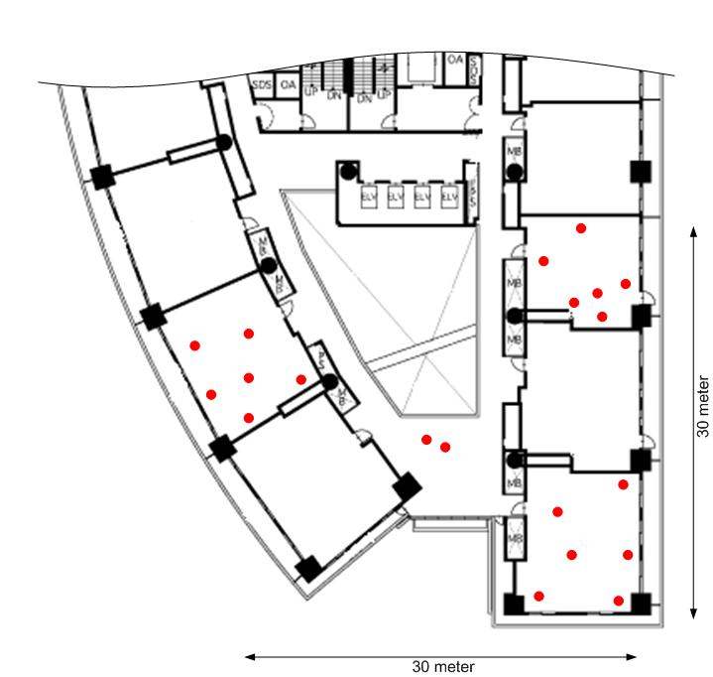
5 | Residen-tial | Digital home  (mis-user)
6 | Office | Small/ Medium Office | In the small/medium office usage model, the primary purposes for the mesh network are to create low-cost, easily deployable networks with reliable coverage throughout an office building. Mesh APs will mostly be dedicated infrastructure devices, but some PCs may also participate as Mesh APs in the network. STAs may be a combination of PCs, laptops, PDAs, printers, telephones and other devices commonly found in an office environment. Since many small/medium offices do not have large IT departments to manage the networking infrastructure, the mesh network should be self-configuring to allow for easy deployment and management.
7 | Office | Large Enterprise  #1 | In the large enterprise usage model, the primary purposes for the mesh network are to create a low-cost, easily deployable wireless network that provides reliable coverage and performance and is manageable by an IT department. Mesh APs will mostly be dedicated infrastructure devices. STAs may be a combination of PCs, laptops, PDAs, printers, mobile and desktop phones and other devices commonly found in an office environment. Since most large enterprises have an IT department to manage the network infrastructure, the mesh network should be centrally manageable.
8 | Office | Large Enterprise  #2
9 | Campus/ Comm-unity Network | University Campus
10 | Campus/ Comm-unity Network | Community Area Network  (residential Internet Access)
11 | Campus/ Comm-unity Network | Inter-building backbone |  | 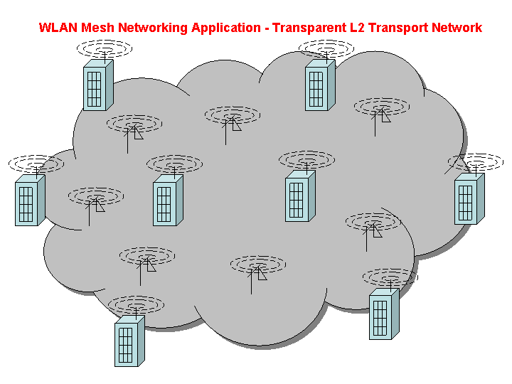  Transparent L2 Transport Service Network
12 | Public Safety | First  Responder | Firefighter company with several trucks responds to fire scene and sets up network. Network tracks firemen with bio-sensors, firemen communicate, upload images, download hazmat information, track air status, equipment location.
13 | Public Safety | Small  Incident Scene | Small incident scene relates to fire/police/emergency personnel responding to an incident scene. Everything is mobile but probably back haul links are from fire trucks or other vehicles that are less mobile, more secure, and have better power. Communications are mostly outdoors but may include communicating with first responders inside (potentially deep inside with contact only by relaying) buildings. Certainly the number of forwarding nodes around may naturally exceed 32 which may require some ability for automatic partitioning into clusters each of which uses 802.11s.
14 | Public Safety | Large Incident Scene | Large incident scene relates to fire/police/emergency personnel responding to an incident scene. Everything is mobile but probably back haul links are from fire trucks or other vehicles that are less mobile, more secure, and have better power. Communications are mostly outdoors but may include communicating with first responders inside (potentially deep inside with contact only by relaying) buildings. Certainly the number of forwarding nodes around may naturally exceed 32 which may require some ability for automatic partitioning into clusters each of which uses 802.11s.
15 | Public Safety | Public Service Grid | Public Service Grid is the case where large areas are blanketed with pole top radios most of which are co-located with remote surveillance cameras or the like and not all of which are wired to a LAN. Variations in radio propagation, equipment/power failures, etc., make static configuration of the link topology of these radios undesirable. Furthermore, mobile units such as patrolmen and police/emergency vehicles should be able to access services via the nearest pole top radio.
16 | Hotzone

Table 4 - Usage Model Characteristics Table

Usage  Model  # | Usage Model Category | Usage Model  Name | Deployment Characteristics |  |  |  |  |  |  |  |  | Traffic Characteristics |  |  | Unique Security Requirements/ Characteristics | Unique Mesh AP/ Mesh Point Device Characteristics (e.g. power, antenna, etc) | Management and Configuration of WLAN Mesh (Self-configuring or Managed?) | Motivations for WLAN Mesh Deployment | Comments
Usage  Model  # | Usage Model Category | Usage Model  Name | Total  # Mesh APs/  Points | Mesh Physical Topology (Physical Area Size/Shape, Include Sample Topology Map) | Mesh  Deployment Environment | Mesh AP/ Point Mobility | Mesh AP / Point Join / Exit Frequency | # Mesh APs/  Points with Portals to Other LANs | #  STAs | STA distri-bution | STA mobility | Use Cases (Including Applications) | Mesh APs/ Points  may be  Application  End-points? | Both application End-points commonly within the WLAN Mesh?
1 | Residen-tial | Digital  Home  #1 | 8 | 10m x 15m | Indoor | Low | Low | 1 | 20 | (Out of scope) |  | 1, 2, 3, 4, 7, 8, 10, 11, 12, 14, 15, 21, 29, 32, 33 | Yes  (SoftAP PCs and CE Devices) | Yes | Central or Distributed Key management | Omni-antenna | Self-  configuring | Low cost, convenient deployment
2 | Residen-tial | Digital home  #2  (full usage of BW) | Relatively small  (6) | 100m^2  Rectangle (1:2)  [ref to sample topology figure R1] | Indoor | Low | Low | Small  (1) | Small  (6) |  |  |  | Yes.  VCR, TV, desktop PC | Yes. | Distributed key management | Omni-antenna  Some of the mesh point and STA has restricted transmission power. | Self-configuring | Seamless connectivity within home, give always connected experience to users. | Measurement parameter for this scenario is :  Overall E-to-E throughput/jitter at the isolated Mesh and BSS deployment.
3 | Residen-tial | Digital home  (network maintenance with power saving) | Relatively small  (6) | 100m^2  Rectangle (1:2)  [ref to sample topology figure R1] | Indoor | Low | Low | Small  (1) | Small  (6) |  |  |  | Yes.  VCR, TV, desktop PC | Yes. | Distributed key management | Omni-antenna  Most of the mesh points are conscious about power conservation.  Some of the mesh point is not forwarding a packet, and are in the doze mode for power saving whle maintaining network configuration. | Self-configuring | Power saving functionality validation for mesh points within mesh network. | Measurement parameter for this scenario is ;  Power saving validation.  Network maintenance signalling complexity.  Quick recovery from doze mode (mesh point).
4 | Residen-tial | Digital home  (co-channel utilization with neighbours) | Medium  (20) | Approx. 900m^2  (30m x 30m)  [ref to sample topology figure R2] | Indoor | Low | Low | Small  (1) | Small  (3) |  |  |  | Yes.  VCR, TV, desktop PC | Yes. | Distributed key management. Different security domain exists in co-channel. | Omni-antenna | Self-configuring | Robustness against co-channel utilization by the different households from radio resource management point of view. | Measurement parameter for this scenario is ;  Fairness among different mesh network owners, and stability of the network.
5 | Residen-tial | Digital home  (mis-user) | Medium  (20) | Approx. 900m^2  (30m x 30m)  [ref to sample topology figure R2] | Indoor | Low | Low | Small  (1) | Small  (3) |  |  |  | Yes.  VCR, TV, desktop PC | Yes. | Malicious aggressor is trying to peep or destroy mesh network. | Omni-antenna | Self-configuring | Robustness against aggressor provides safety operation of wireless network. | Measurement parameter for this scenario is ;  Robustness against aggressor, and stability of the network.
6 | Office | Small/ Medium Office | 16 | 20m x 40m | Indoor | Low | Low | 2 | 80 |  |  | 1, 9, 10, 18, 29, 30, 31, 33, 36 | Yes  (SoftAP PCs) | Yes | Central or Distributed Key management | Omni-antenna | Self- configuring | Low cost, convenient deployment, reliable coverage
7 | Office | Large Enterprise  #1 | 32 | 6000m^2 | Indoor | Low | Low | 7 | 300 |  |  | 10, 31, 33, 1, 29, 9, 36, 18, 30 | No (Dedicated Mesh APs) | Yes  (Voice, Printing, Projector, etc.) | Central Key Management | Omni-antenna | Managed Configuration | Low cost, convenient deployment, reliable coverage
8 | Office | Large Enterprise  #2 | Large  (50-100) | 8000 m^2  (per AP) | Indoor | Fix | N/A | Medium  (5-10) | Large  (500-2000) |  |  | 1, 9, 10, 11,13,16,18, 29,30, 31, 36,37 | No | No | Central Key management | Directional-antenna | Managed configuration | Productivity, accessibility and lower cost infrastructure
9 | Campus/ Comm-unity Network | University Campus | Large (30-50) | 50 k m^2 – 100 k m^2  (per AP) | Outdoor | Fix | N/A | Medium (4-5) | Large (300-1000) |  |  | 2,9,10,11,13, 18,20,21,31 | No | No | Central Key management | Directional antenna | Managed configuration | Accessibility, lower cost infrastructure, border coverage
10 | Campus/ Comm-unity Network | Community Area Network  (residential Internet Access) | Large (100) | 100 k m^2  (per AP) | Outdoor | Fix | N/A | Medium (10) | Large (2000 – 3000) |  |  | 1,2,11,14,21 | No | No | Central Key  management | Directional antenna | Managed configuration | Wireless Internet, lower cost infrastructure, scalability
11 | Campus/ Comm-unity Network | Inter-building backbone | Large | 5km^2  [ref to topology figure 1] | Outdoor | Fixed | Low  (restricted access only) | Medium  (8-10)  * Not sure what this field is for? Is it meant for the ratio of # of mesh points to a portal? | N/A |  |  | 6-9, 14, 15, 19, 23, 24, 25 | Yes  (Access switches could be Mesh Portals) | Yes | Distributed key management | Omni, Sector, Smart-antenna | Managed configuration | Reduced deployment time and cost, reliable coverage
12 | Public Safety | First  Responder | Large  (32) | 250 m^2  Circle  [ref to sample topology figure] | Indoor/Outdoor | Medium | Medium | Medium  (6-8) | Medium  (50) |  |  | Apps: 1,7,8,9,14,15,19; Use: 7,8,9,10,13,15,28,30,31,32,33,37 | Yes | Yes | Central or Distributed Key management | Omni or directional | Self-  configuring | No Infrasturcture,Low cost,fast depoloy | Wireless portal to Internet (cellular)
13 | Public Safety | Small  Incident Scene | Medium (20) | 1000 m^2 | Mostly Outdoor | High | High | Small  (2-3) | Small  (30) |  |  | 11, 37, 41, 42 | Yes | Yes | Central Key management, users hierarchically organized |  | Self-  configuring | Mesh improves range, reachability, battery life
14 | Public Safety | Large Incident Scene | Very Large (100) | 1 km^2 | Mostly Outdoor | High | High | Large  (10-20) | Large (250) |  |  | 11, 37, 41, 42 | Yes | Yes | Like DE-2 but may have several organizations with disjoint management |  | Self-  configuring | Mesh improves range, reachability, battery life
15 | Public Safety | Public Service Grid | Very Large (100s) | 100 km^2 | Outdoor | Low | Low | Very Large (50-100) | Large (250) |  |  | 7, 11, 13, 37, 41, 42 | Yes | No, most paths back to persons/services on fixed LAN |  |  | Self-  configuring | Low cost, convenient deployment, reliable coverage
16 | Hotzone

Detailed Simulation Scenarios
This section is a placeholder for more detailed descriptions of usage models, including enough details to specify simulation scenarios. These simulation scenarios will include a specification of a representative topology, one or more channel model, mapping of application endpoints to devices in the topology, and other simulation parameters.

Table 5 - Environment to Channel Model Mapping
Model | Environment
A | Flat fading (no multipath)
B | Residential
C | Residential / Small Office
D | Typical Office
E | Large Office
F | Large Space (indoors / outdoors)

Channel model specifications TBD.

Note, this corresponds to a loss of a 1024B MSDU per hour. The TS PDU PLR is higher than this. It is not known what is the effect to the decoder of giving it burst packet losses.
Note, a PLR of 10^-7 will not be measurable in our simulation technologies.

